DESIGNATION - ELKSHOT
PID - FU1449

N 35 21 18.0

W 119 20 28.9

Recovered as described

Additional recovery notes:
Needs new witness post.

To reach from Stockdale exit on I-5. From intersection of Stockdale Hwy and I-5 go west on Stockdale 0.3mi and the station on the right.
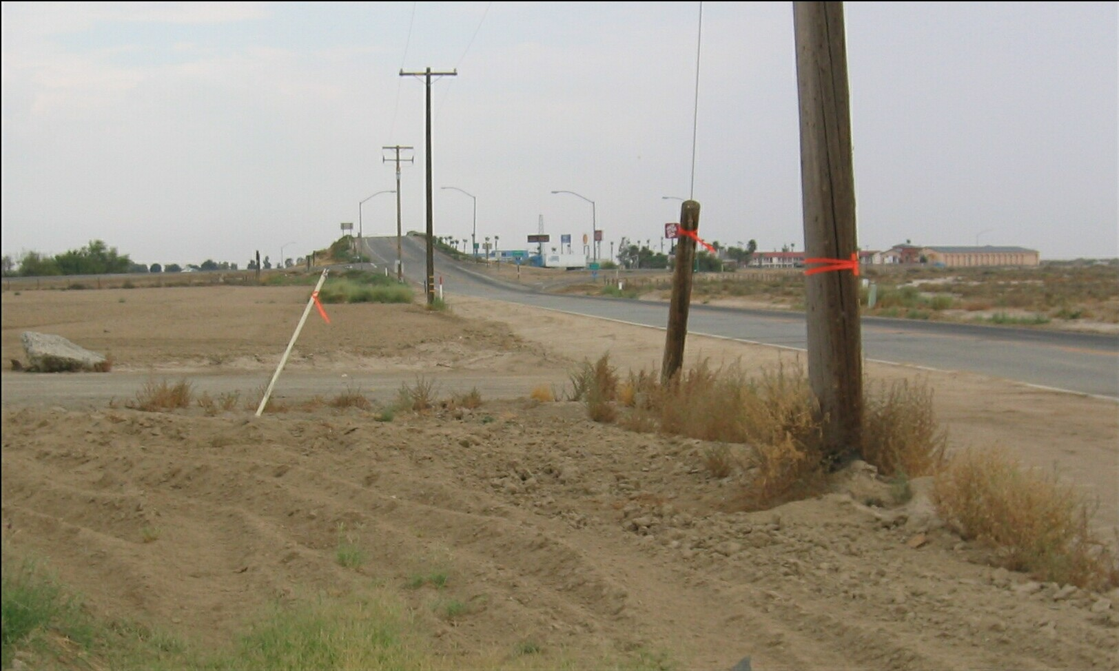
Mon

