DESIGNATION - Y 662
PID - GU1758

N 36 17 45.8

W 120 18 07.9

Recovered as described 07-30-2003

Additional recovery notes:
Designation illegible on disk
To reach from Interstate-5, Hwy 33, and Hwy 145 intersection go southwest on Hwy 33 for 2.1 miles to a side road right (Coalinga-Mendota Rd). Turn right (north) on Coalinga-Mendota Rd go 0.9 miles to the station on the right.
Station is located 9.5 feet west of a barb wire fence, 43.0 feet east of C/L of road, 200 feet +/- south of a PG&E line, and 59 feet south of the south gatepost of a gate to a field.
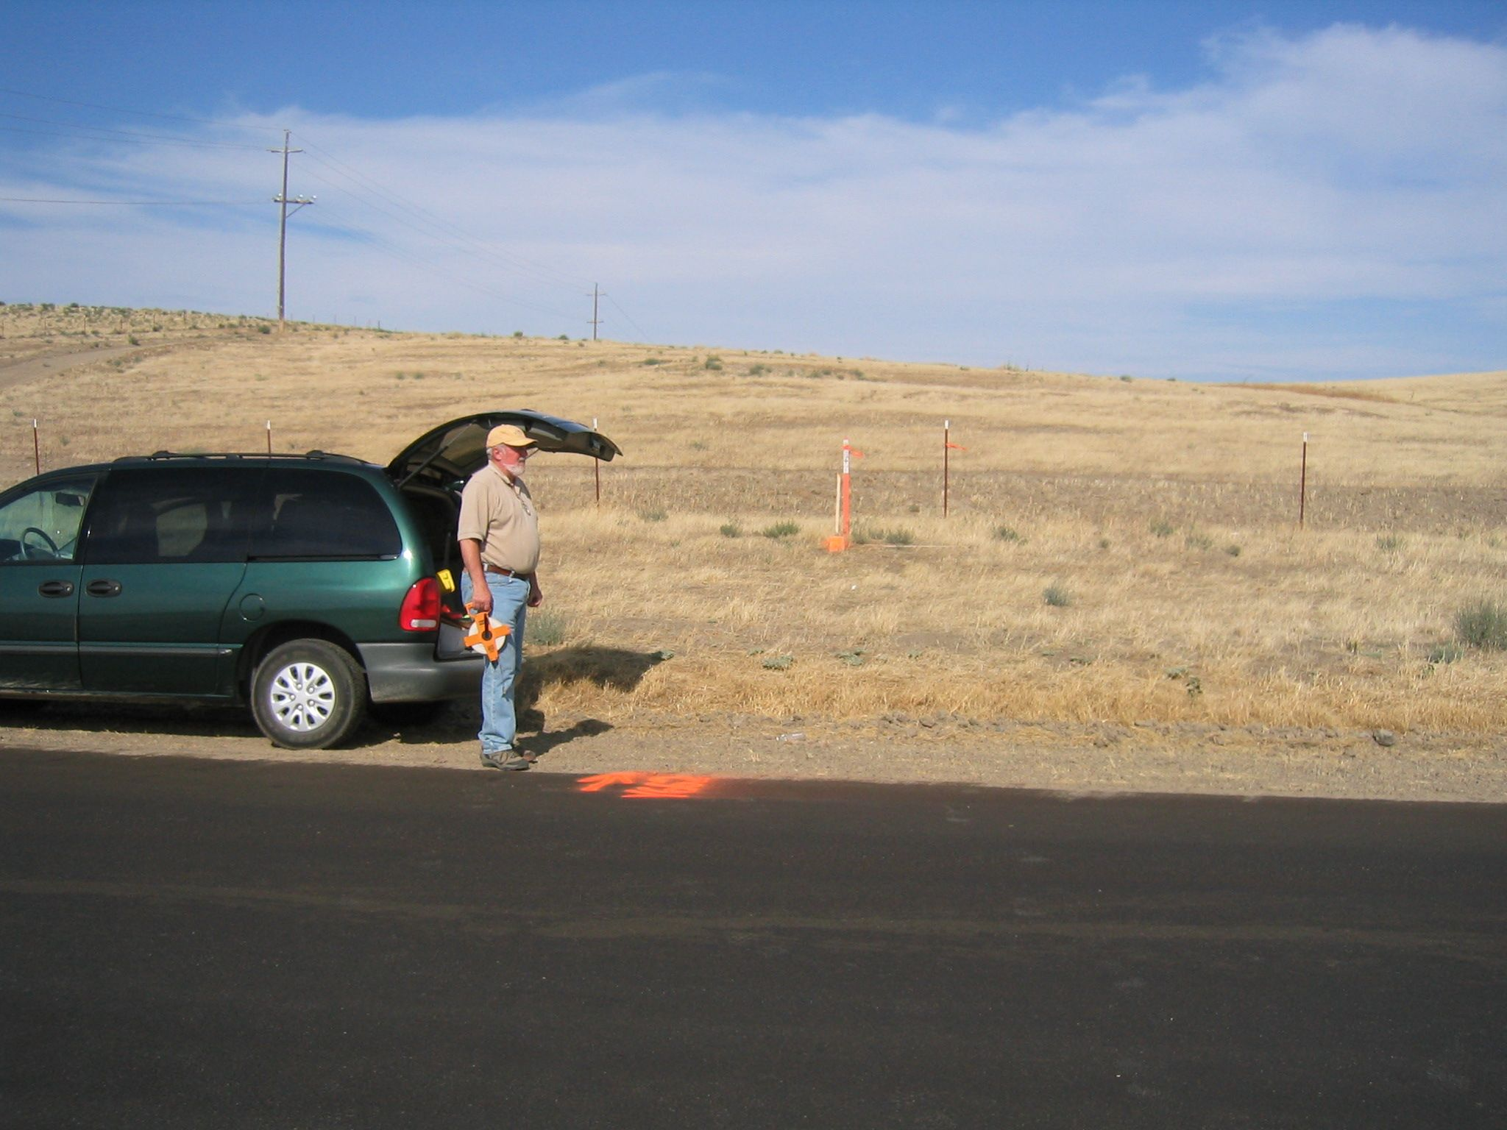
MON

