DESIGNATION - TULE
PID - NONE, SET NEW MONUMENT

N 35 05 14.6

W 119 19 17.9

Set new monument in top of concrete wing wall over irrigation canal.

Additional recovery notes:
Station is west of and adjacent to Hwy 99 approximately 8.4mi south of Tulare and 1.6mi north of Tipton. To reach from the Hwy 190 (Popular Ave.) exit off Hwy 99: From the intersection of Hwy 190 and Hwy 99 go west on Hwy 190 0.6mi to a crossroad at South Wesling Rd. Turn right (north) onto South Wesling Rd. and go 1.1mi to the Olive Ave street crossing. Continue north 1.6mi and to the Station on the left. Station is adjacent to AT&T communication site no2472.
Located 31.0 ft west of the C/L Wesling Rd., 34.5 ft east from the northeast fence corner of the AT&T facility, and 65 ft southwest of a power pole with transformer and one guy anchor.
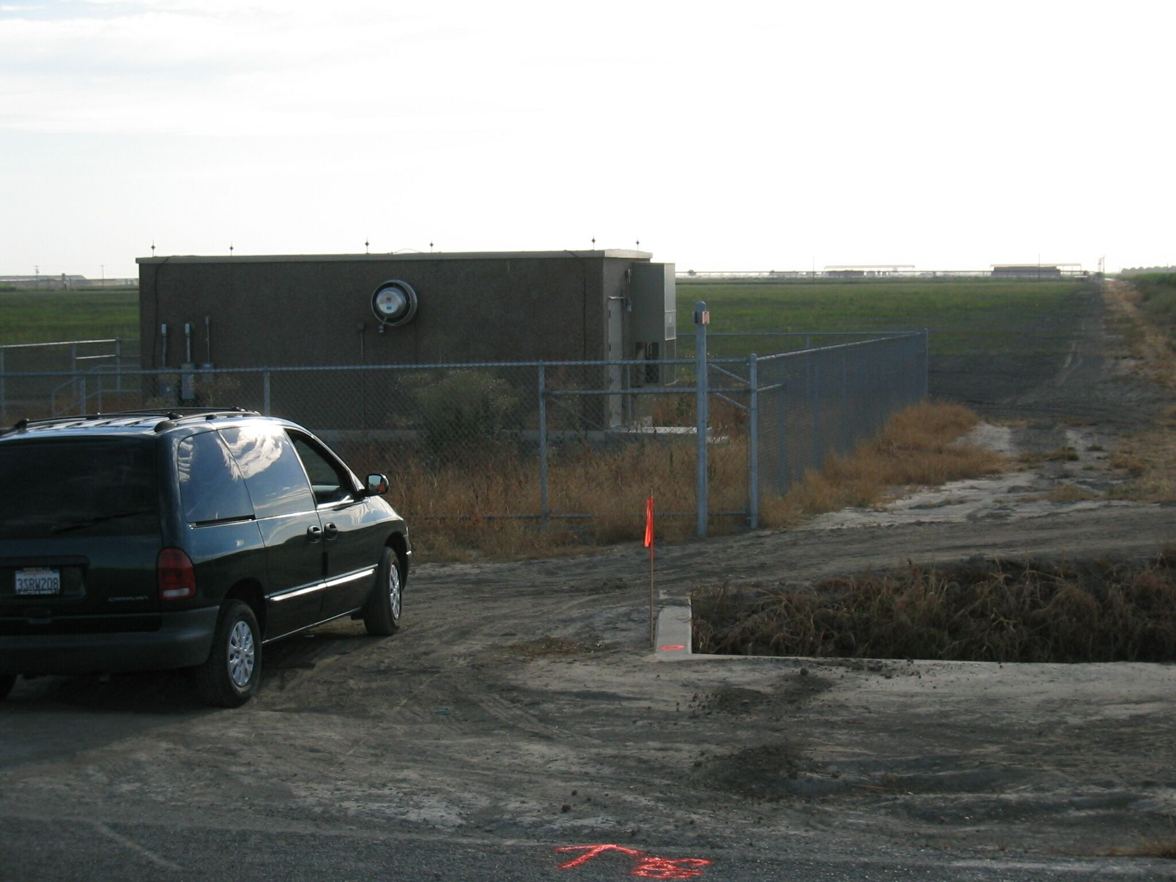
Set new
Monument

