DESIGNATION - SIXTH
PID - NONE, SET NEW MONUMENT

N 36 19 41.0

W 119 33 54.0

Set new monument in wing wall of irrigation canal crossing.

Additional recovery notes:
Station is located south of Hwy 198 approximately 4.5 mile east of Hanford. From the intersection of Hwy 198 and Hwy 99 go west on Hwy 198 approximately 8.7mi to a crossroad (6th Ave) and the station of the left. Station is on top of a wing wall of an irrigation canal crossing under Hwy 198 and located at the southeast corner of the intersection of Hwy 198 and 6th Ave.
Station is located 45.0 ft east of C/L of 6th Ave, 40.0 ft south of C/L Hwy 198, and
2.0 ft northeast of the southwest end of the west wing wall.
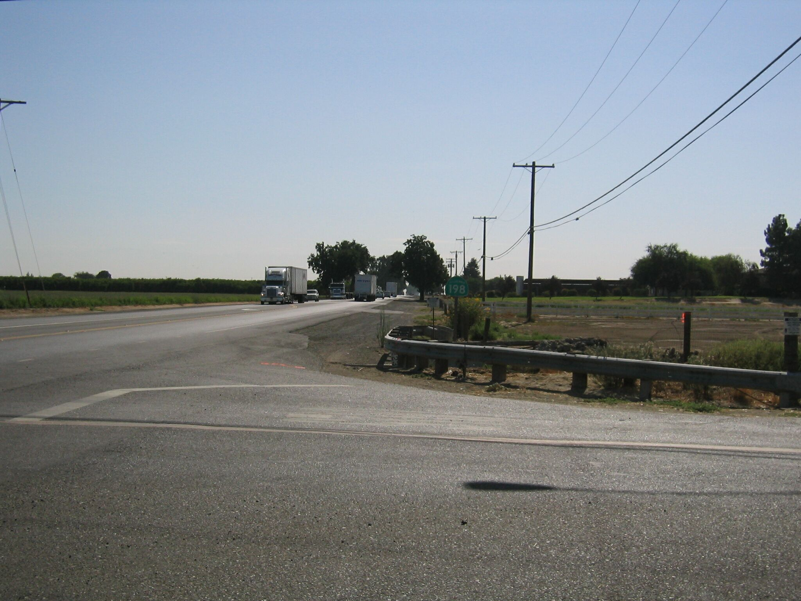
Set new
Monument

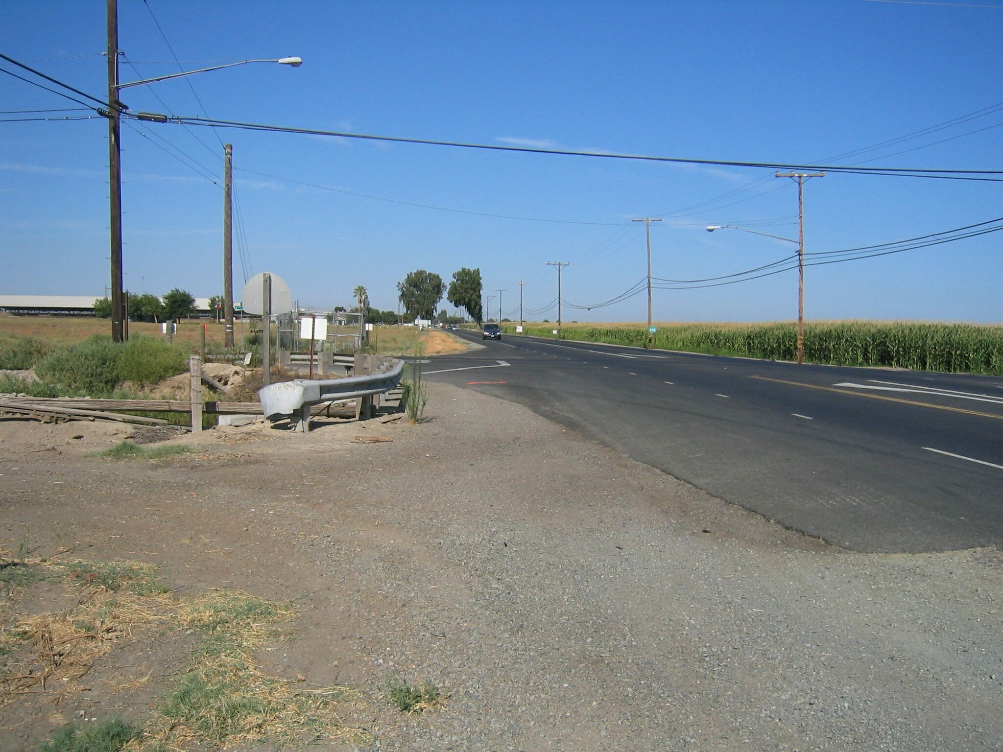
Set new
Monument

