DESIGNATION - S 1204
PID - FU1113

N 35 53 31.0

W 119 16 27.8

Recovered as described 8-13-2003

Additional recovery notes:
Monument is located at the west-end of the overpass, on the north side of street, in the top of curb.
Note: “NO RIGHT TURN” sign located 4 ft due west of station is an obstruction that should be moved or lowered.
Station is 16.0 ft north of C/L road and 0.8 ft east of the west-end of bridge abutment.

See photo next page.

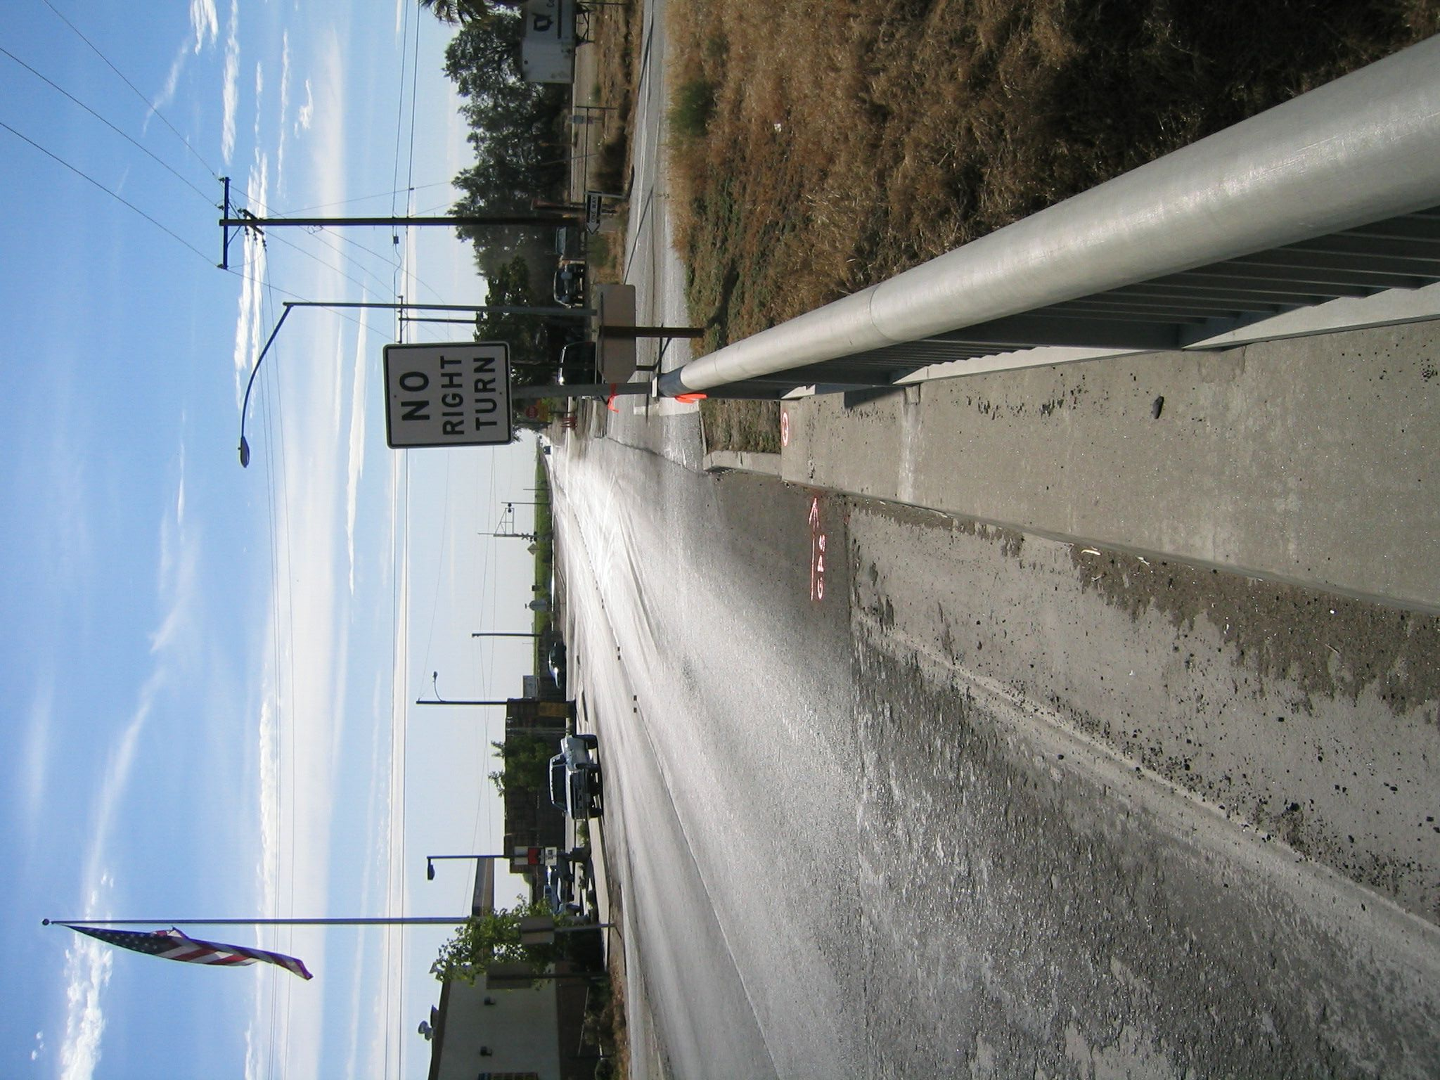
Mon

