DESIGNATION - QUAIL
PID - NONE, NEW MONUMENT

N 36 00 26.8

W 119 18 20.3

Set new monument in top of head wall.

Additional recovery notes:
Station is located west of the Ave 120 and Hwy 99 interchange approximately 16.5mi north of Dalano and 14mi south of Tulare. To reach from the intersection of Ave 120 and Hwy 99, go west on Ave 120 for 0.2mi to a side road left (Road 120) and the station on the left. Located 1.0 ft north of the south end of a head wall, 83.5 ft south of C/L Ave 120 and 29.0 ft west of the C/L Road 120.
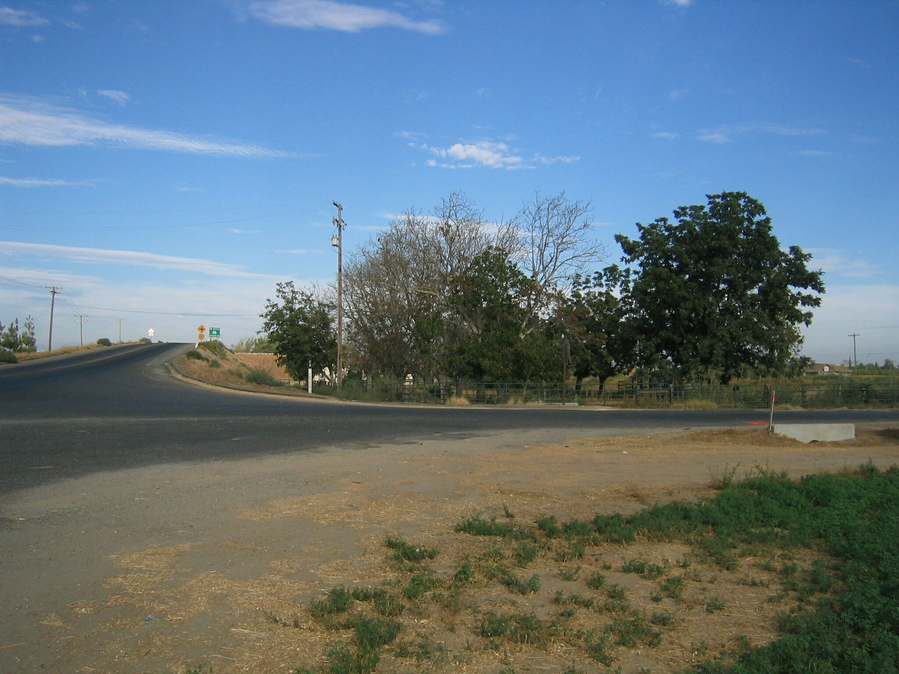
Set new
Monument

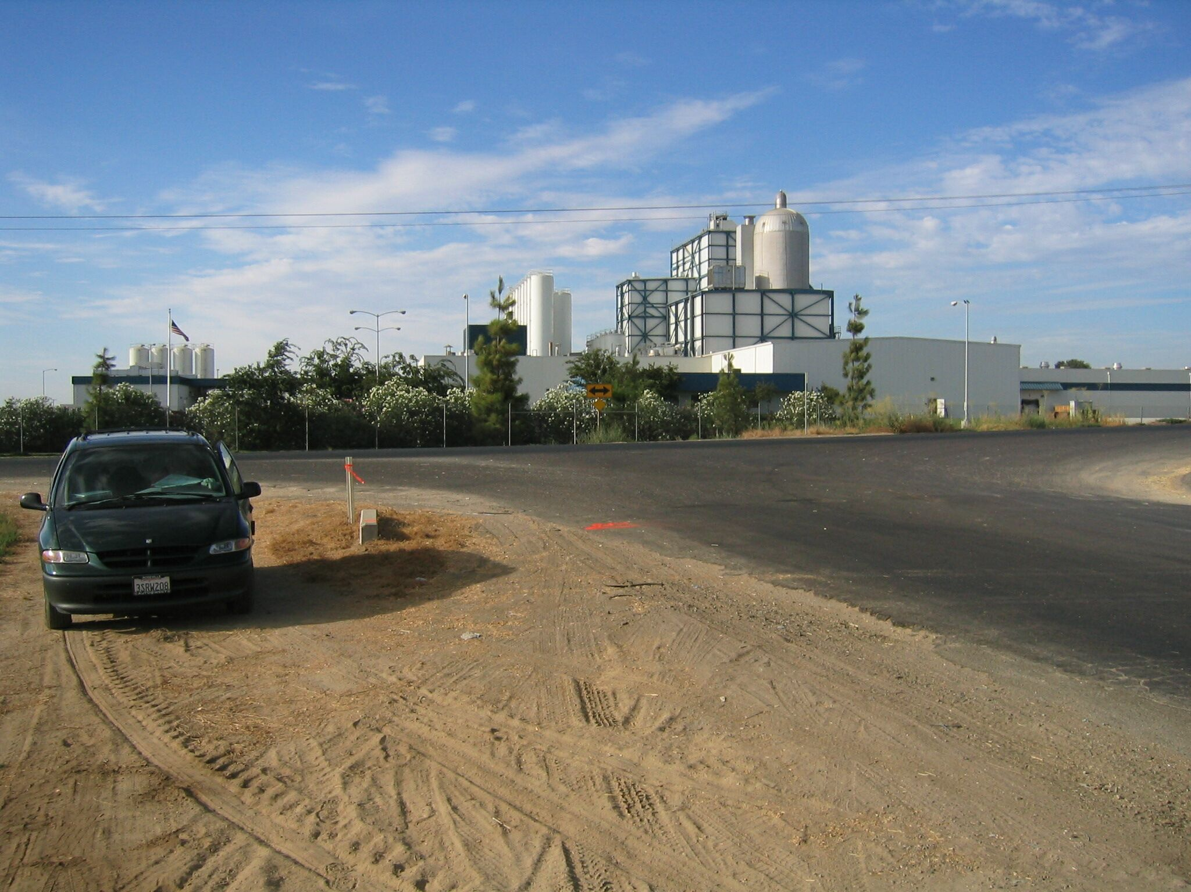
Set new
Monument

