DESIGNATION - Q 1228
PID - GT1055

N 36 15 20.4

W 119 59 40.4

Recovered as described 8-13.2003

Additional recovery notes:

Note from PID: Power pole is gone and Jameson Ave not marked.
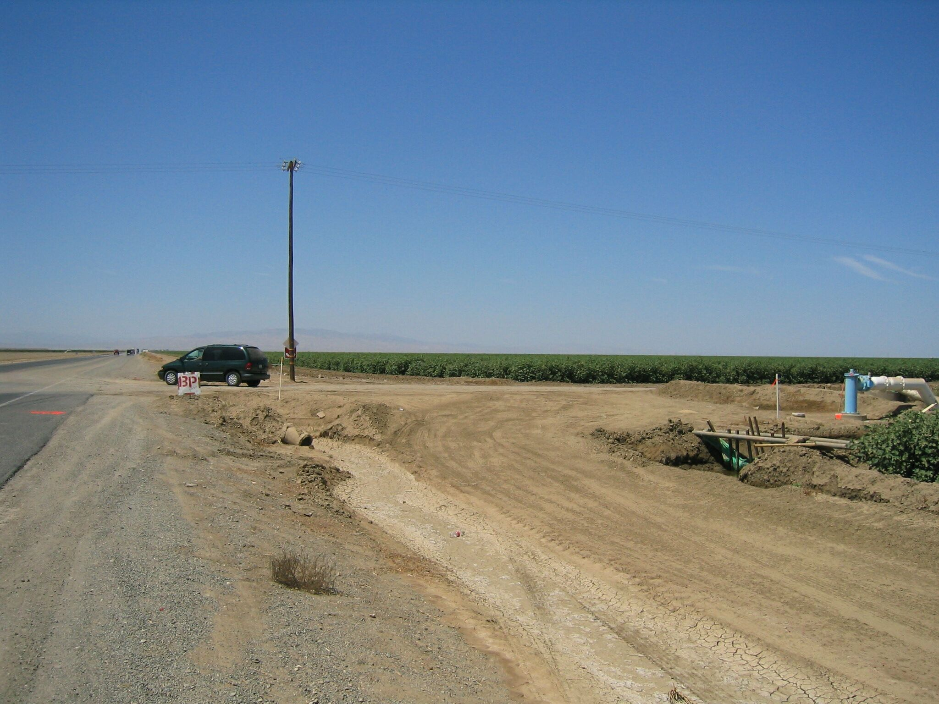
West
Mon

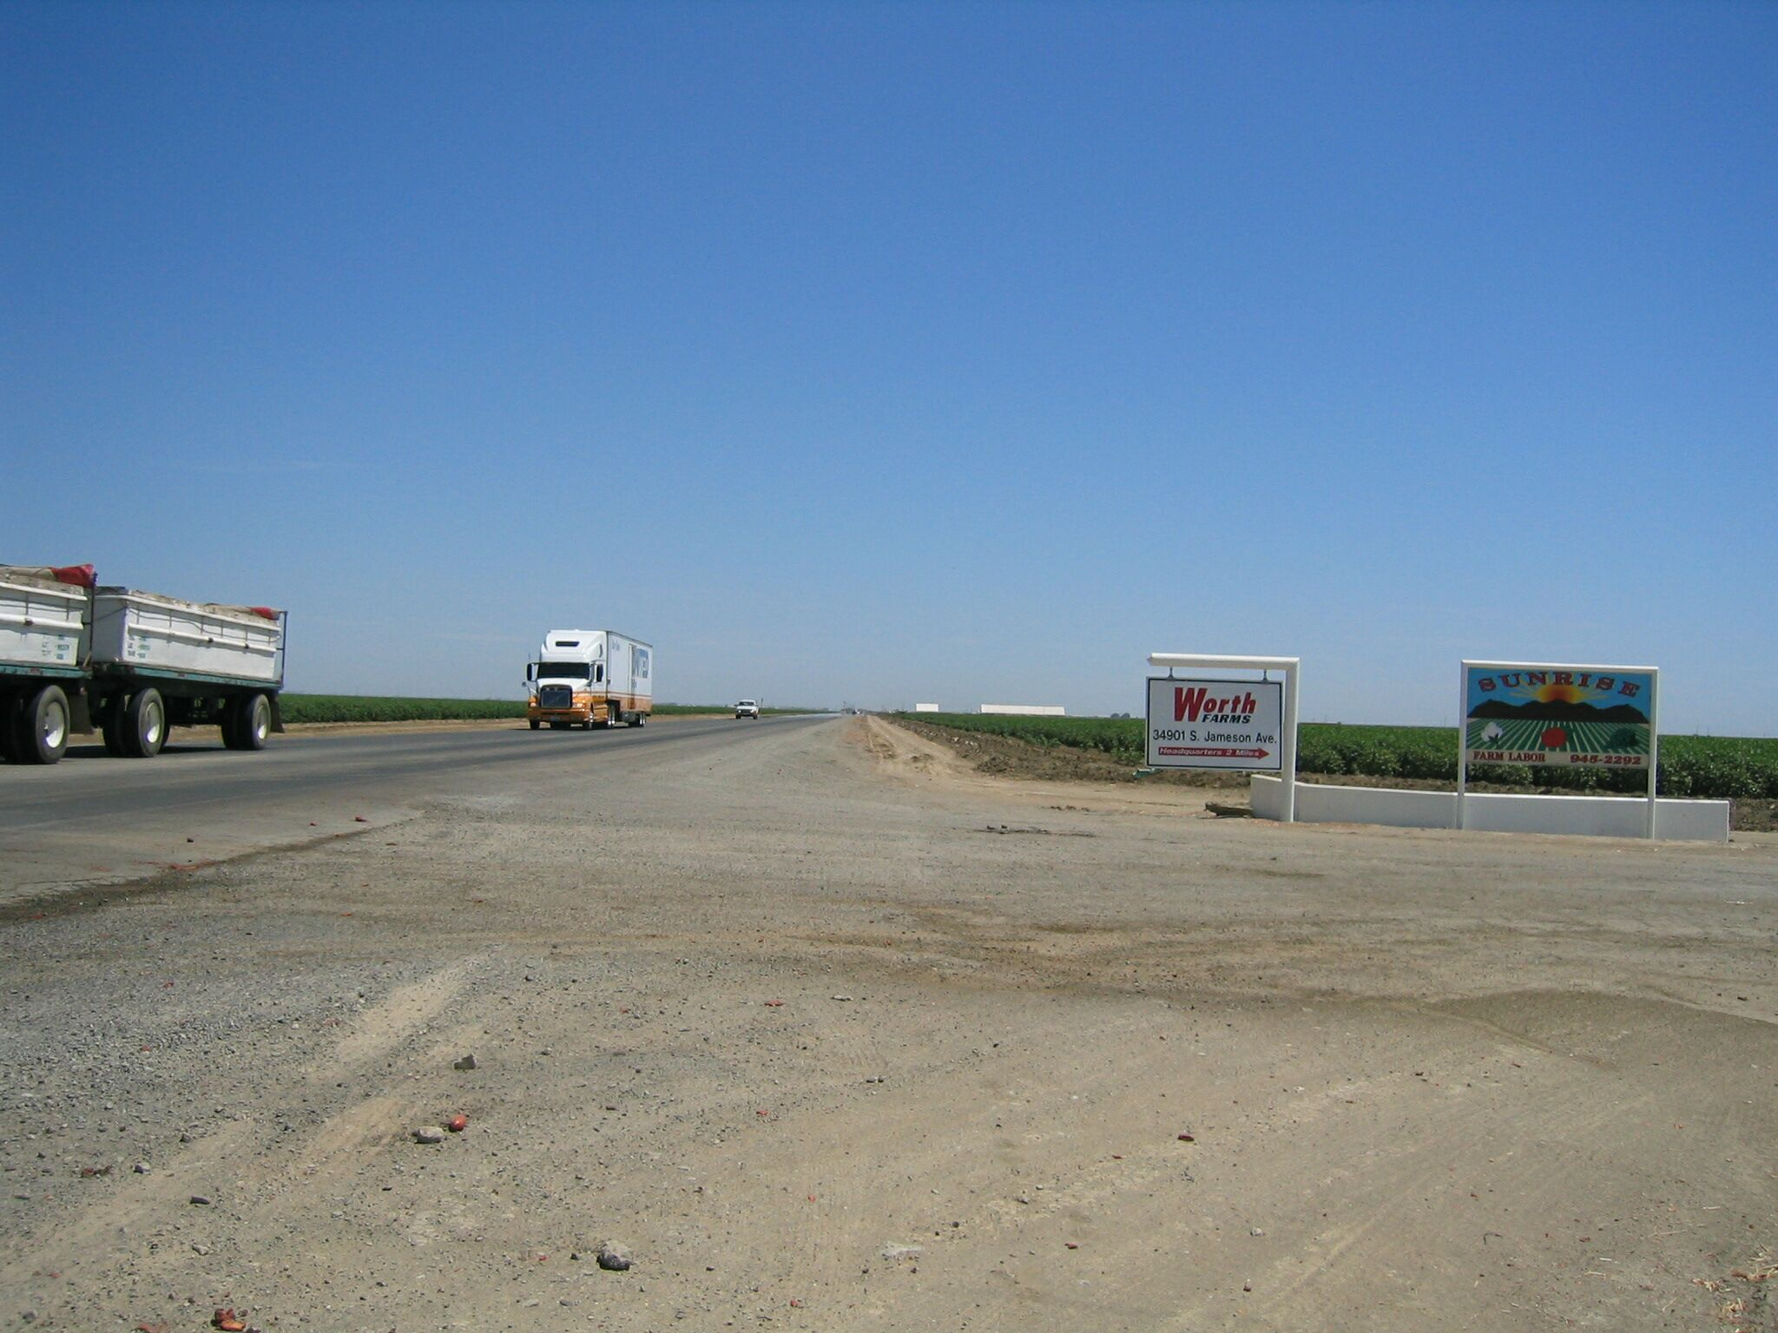
East
Mon

