DESIGNATION - P 817 RESET
PID - HS1089

N 37 04 59.9

W 120 21 11.8

Recovered as described.

Additional recovery notes:
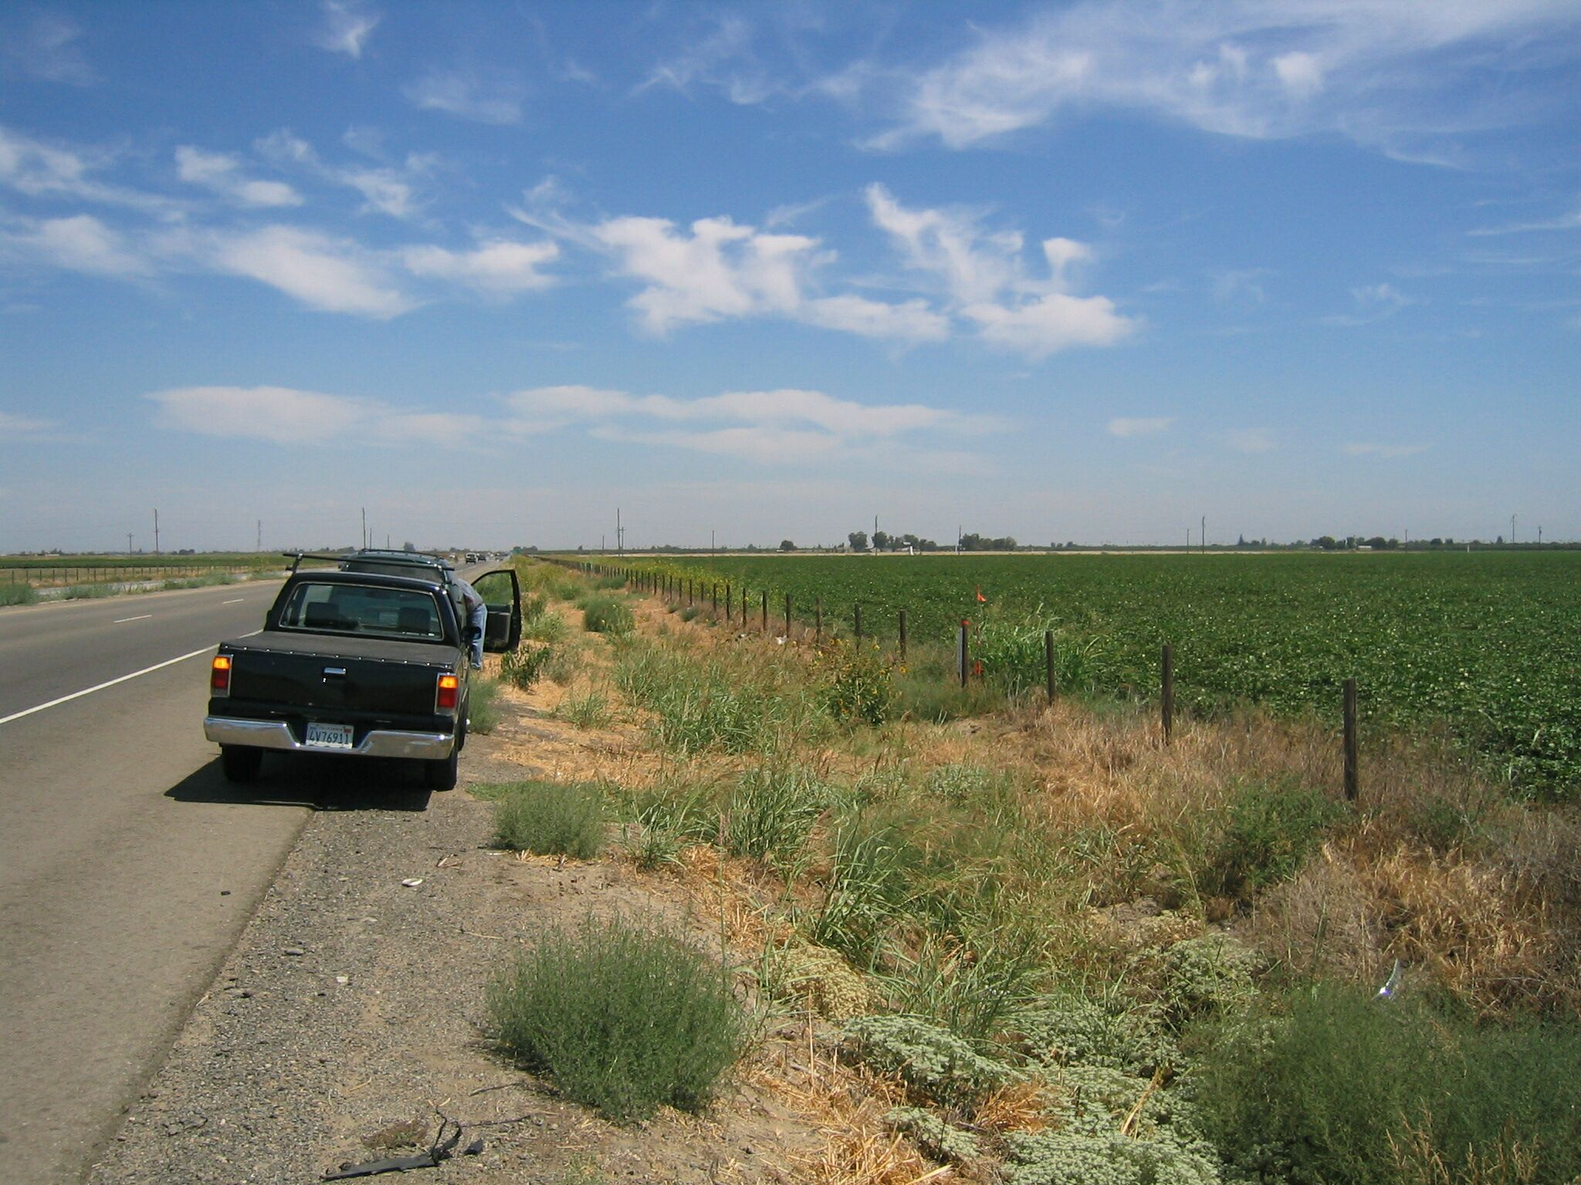
Mon

