DESIGNATION - N 460 RESET
PID - GT0973

N 36 18 49.0

W 119 43 20.5

Recovered 8-13-2003

Additional recovery notes:
Station is located approximately 4.4mi west of Hanford and 3.7mi east of Lemoore on Hanford Armona Rd on the top of a headwall of a box culvert.
To reach from the 14th Ave. exit off Hwy 198: From the intersection of 14th Ave and Hwy 198 go north on 14th Ave. 0.35mi to a crossroad (Hanford Armona Rd). Turn left on to Hanford Armona Rd. and go west 0.5mi to a stop sign, continue west 0.2mi to the station on the right.
Monument is located 21.0 ft north of the C/L road, 38.5 ft east of a dirt road going north and 49.2 ft from a utility pole no. 1822687E.
Monument is located on top of a box culvert head wall at an angle point in the wall.
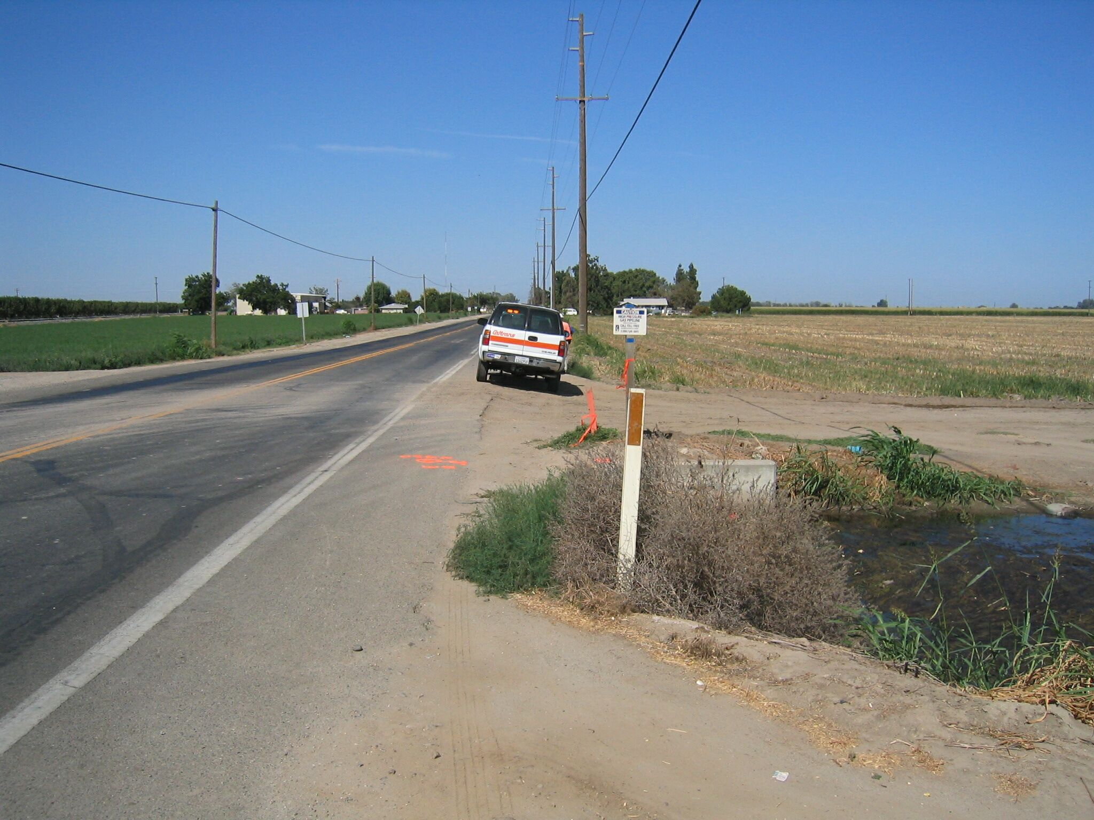
West
Mon

