DESIGNATION - LEMOORE RESET
PID - GT0999

N 36 18 14.6

W 119 46 56.1

Recovered 8-13-2003

Additional recovery notes:
Note: Animal Clinic Sign has been moved (see PID GT0999)
Station is located in the town of Lemoore.
To reach from Lemoore Ave. exit off Hwy 198: From intersection of Lemoore Ave. and Hwy 198 go north on Lemoore Ave. 0.85mi (crossing the Rail Road tracts at 0.8mi) to F St. a side road left. Turn left onto F St. (west) and go 0.1mi to the station on the left.
Monument is located in an empty lot near the rail road tracts, 59.4 ft southwest of Lemoore Animal Clinic sign, 83 ft south of F St. and 52.5 ft north of north rail of a rail road siding.
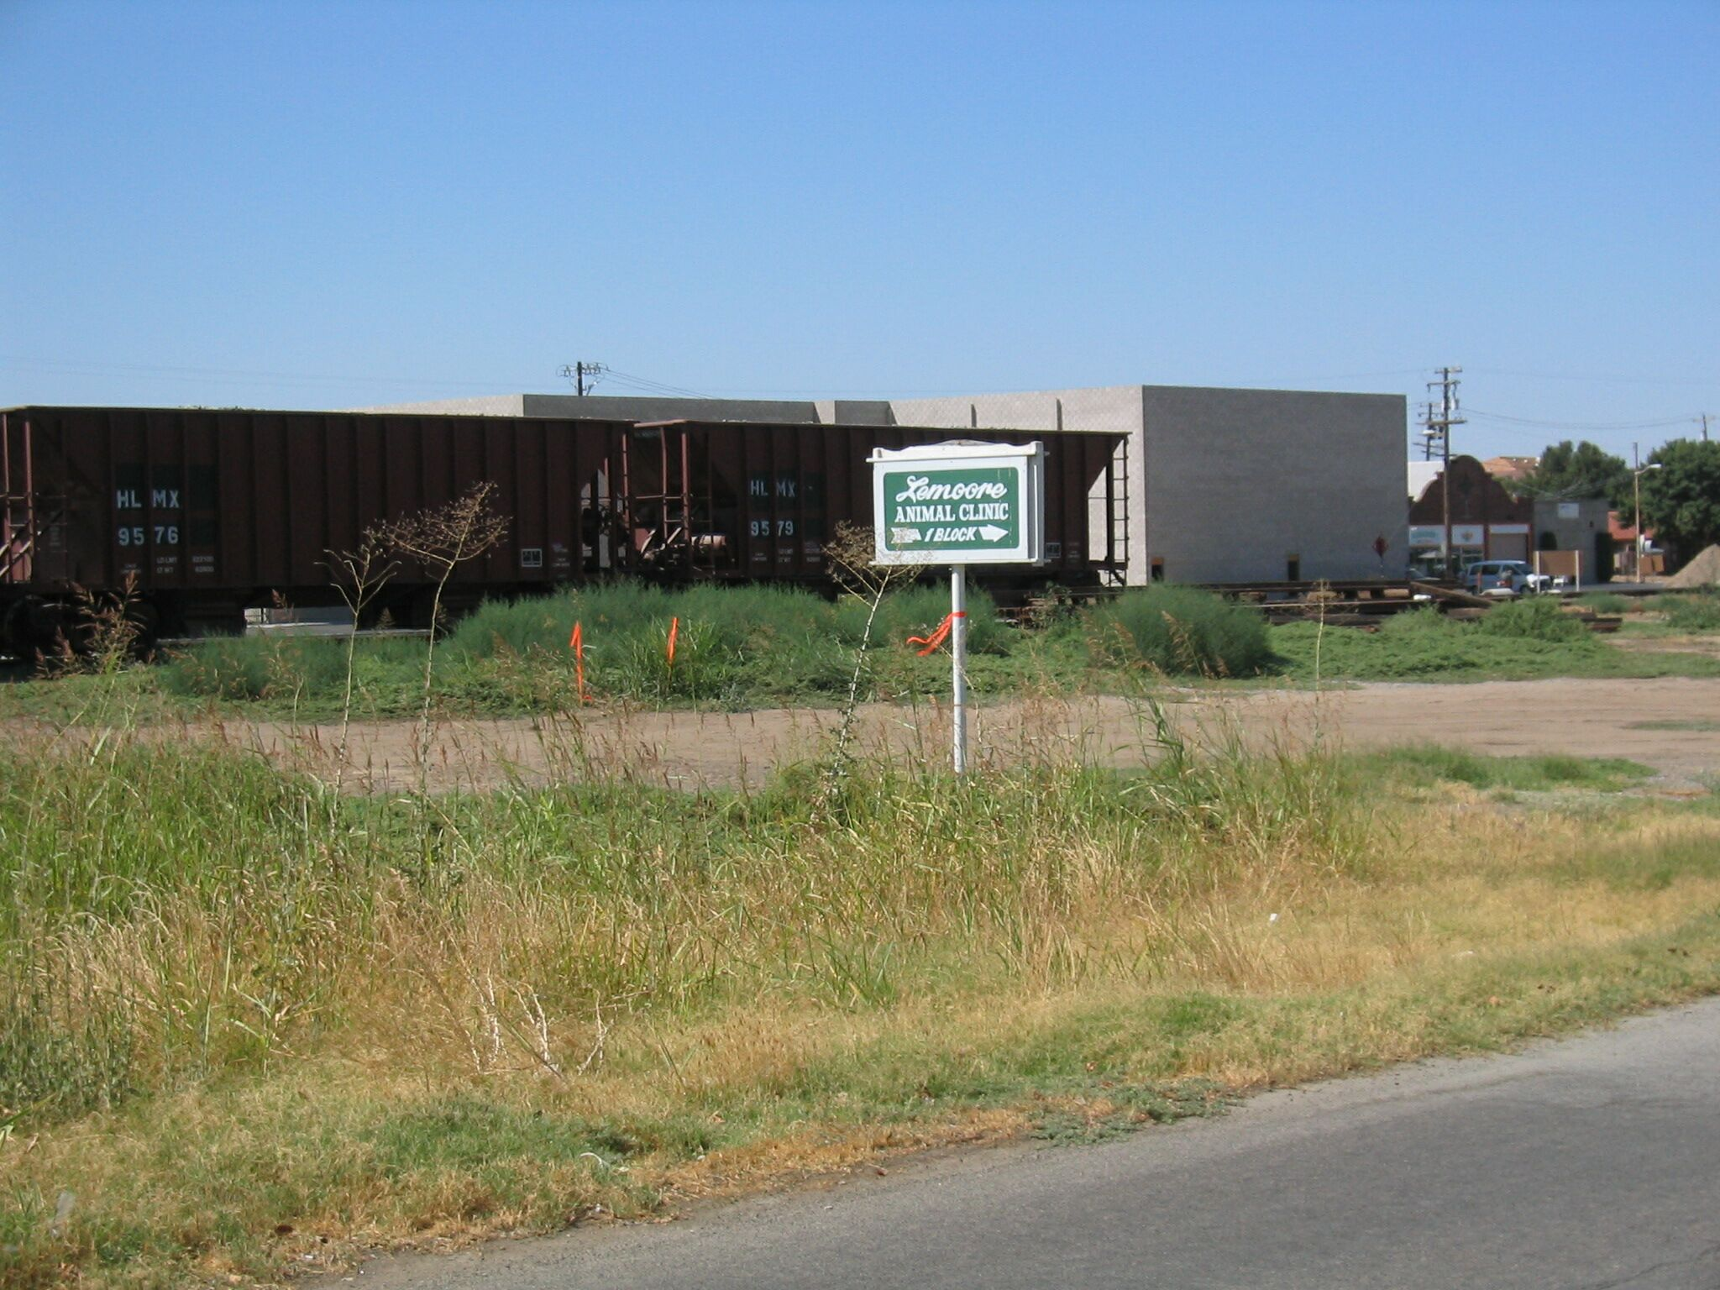
Mon

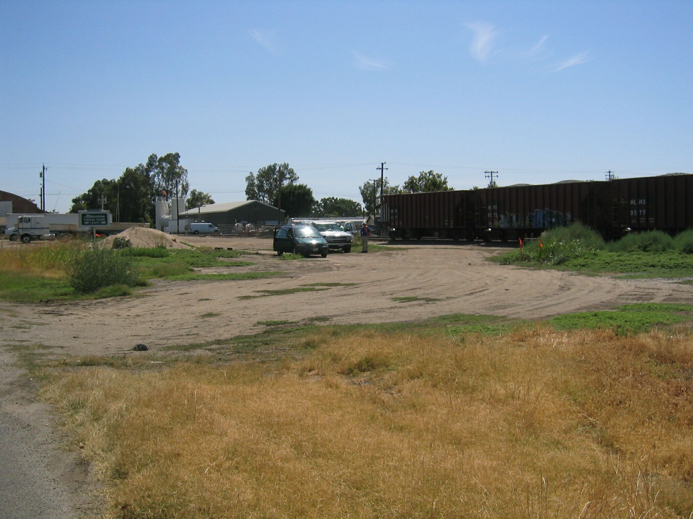
Mon

