DESIGNATION - LOST 2
PID - AA8968

N 35 40 00.8

W 119 41 22.9

Recovered as described 07-29-2003

Additional recovery notes:

Station is located near the intersection of I-5 and Lost Hills Road, northeast of I-5 and east of Lost Hills Rd. Station is about 300 feet at N30° E from the intersection of I-5 and Lost Hills Road. Station is at the intersection of two dirt roads on C/L +/- of the north-south dirt road and 5 feet north of the C/L of a dirt road running east.

Reference marks no 4 and 5 recovered as described.

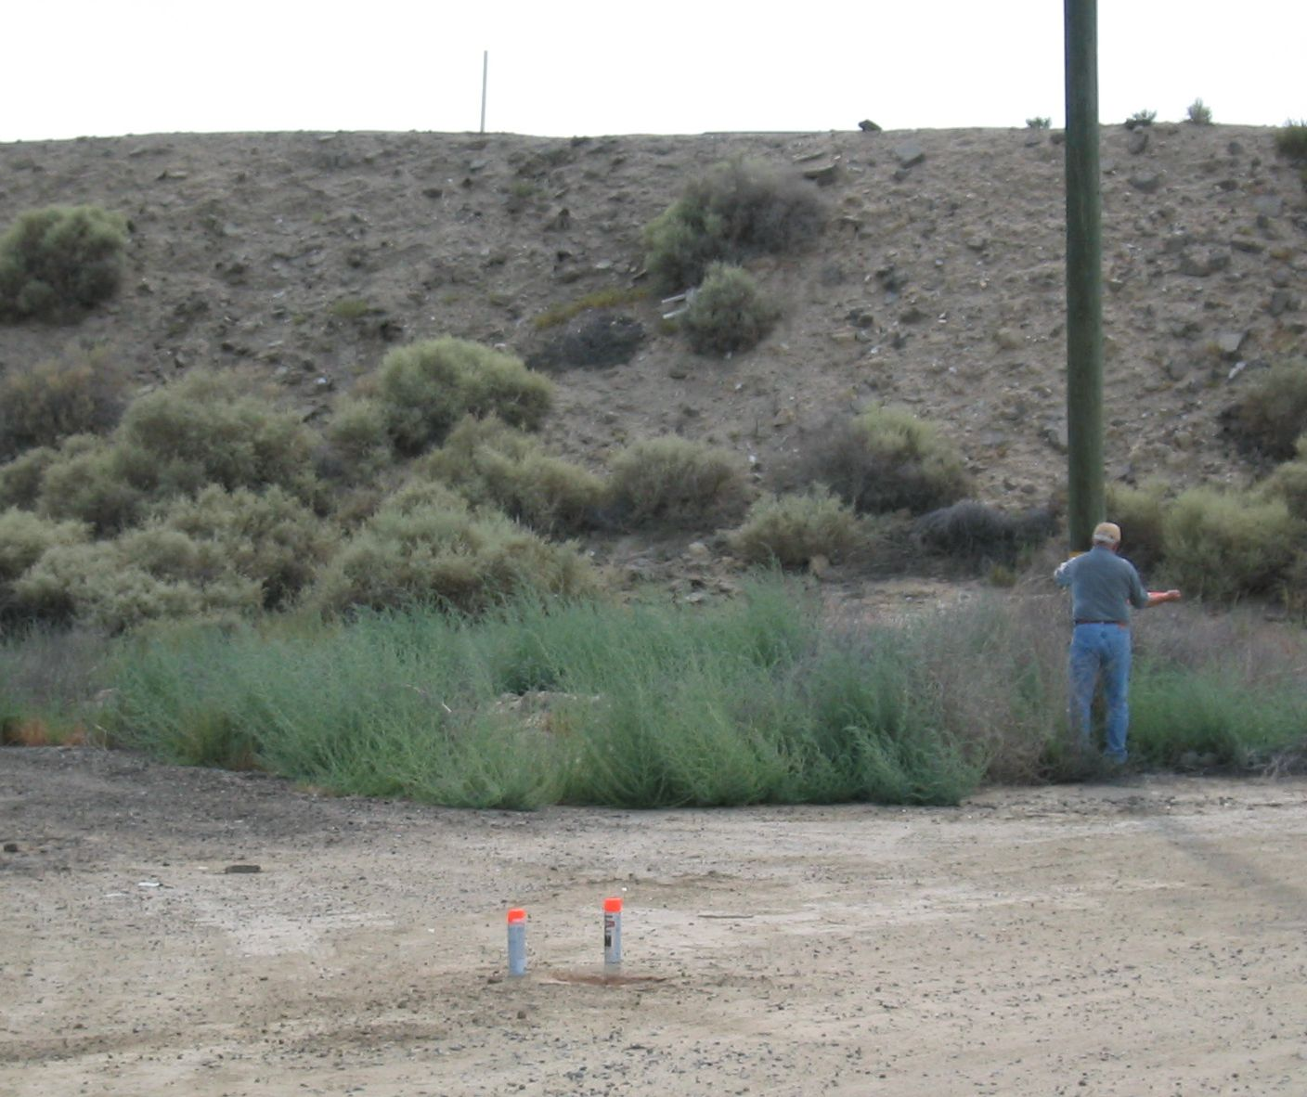
To reach from the Twisselman Road exit on I-5: From the intersection of Twisselman Rd and I-5 go east on Twisselman Rd. for 2.8 miles to a ‘T’ intersection at Lost Hills Rd. Turn right (south) and go 4.4 miles to a dirt side road left (0.2 miles north of intersection of Lost Hills Rd and I-5). Turn left and continue south parallel to Lost Hills Rd 0.2 miles to the station in the center of the road.
Lost Hills Road
Mon

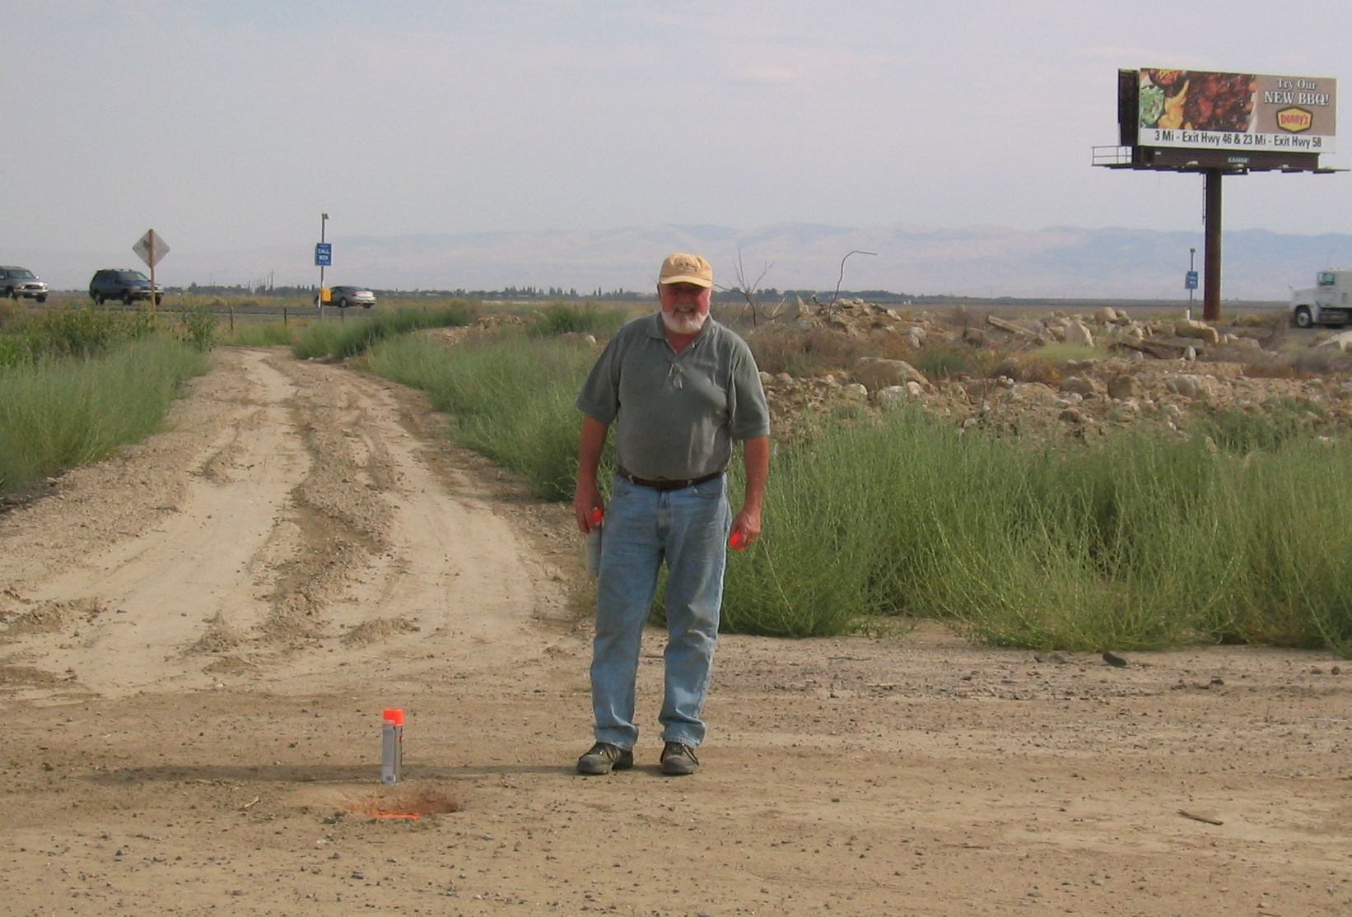
MON

