DESIGNATION - 125.31 L
PID - GU0884
Recovered as described 7-28-2003

N 36 32 12.3
W 120 23 20.7

Additional recovery notes:
Use of traffic cones advised.
To reach from the junction of I-5 and Hwy 33 go north on Hwy 33 approximately 7.1mi to bridge no. 42-272 crossing the California Aqueduct and the station on the left.

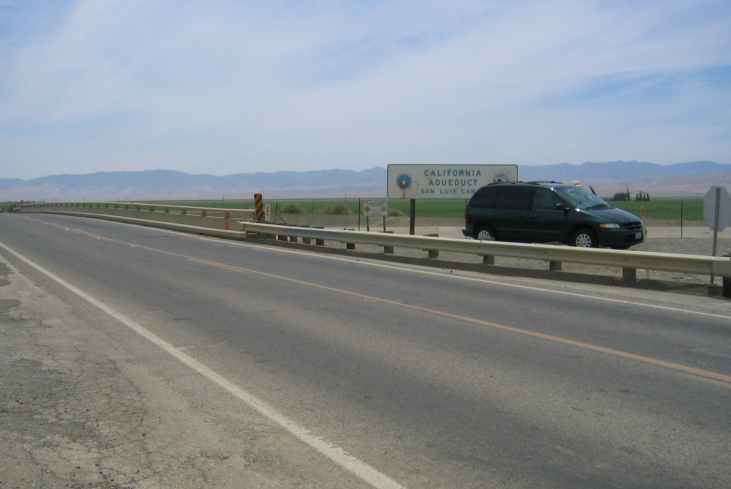
To reach from the junction of I-5 and Kamm go east on Kamm 5.6 miles to Hwy 33 and a ‘t’ intersection, go left (north) on Hwy 33 0.2mi to bridge no. 42-272 crossing the California Aqueduct and the station on the left
SOUTH
MON

