DESIGNATION - HPGN D CA 06 JK
PID - AC6132

N 35 57 58.2

W 119 17 36.2

Recovered as described 8-13-2003

Additional recovery notes:
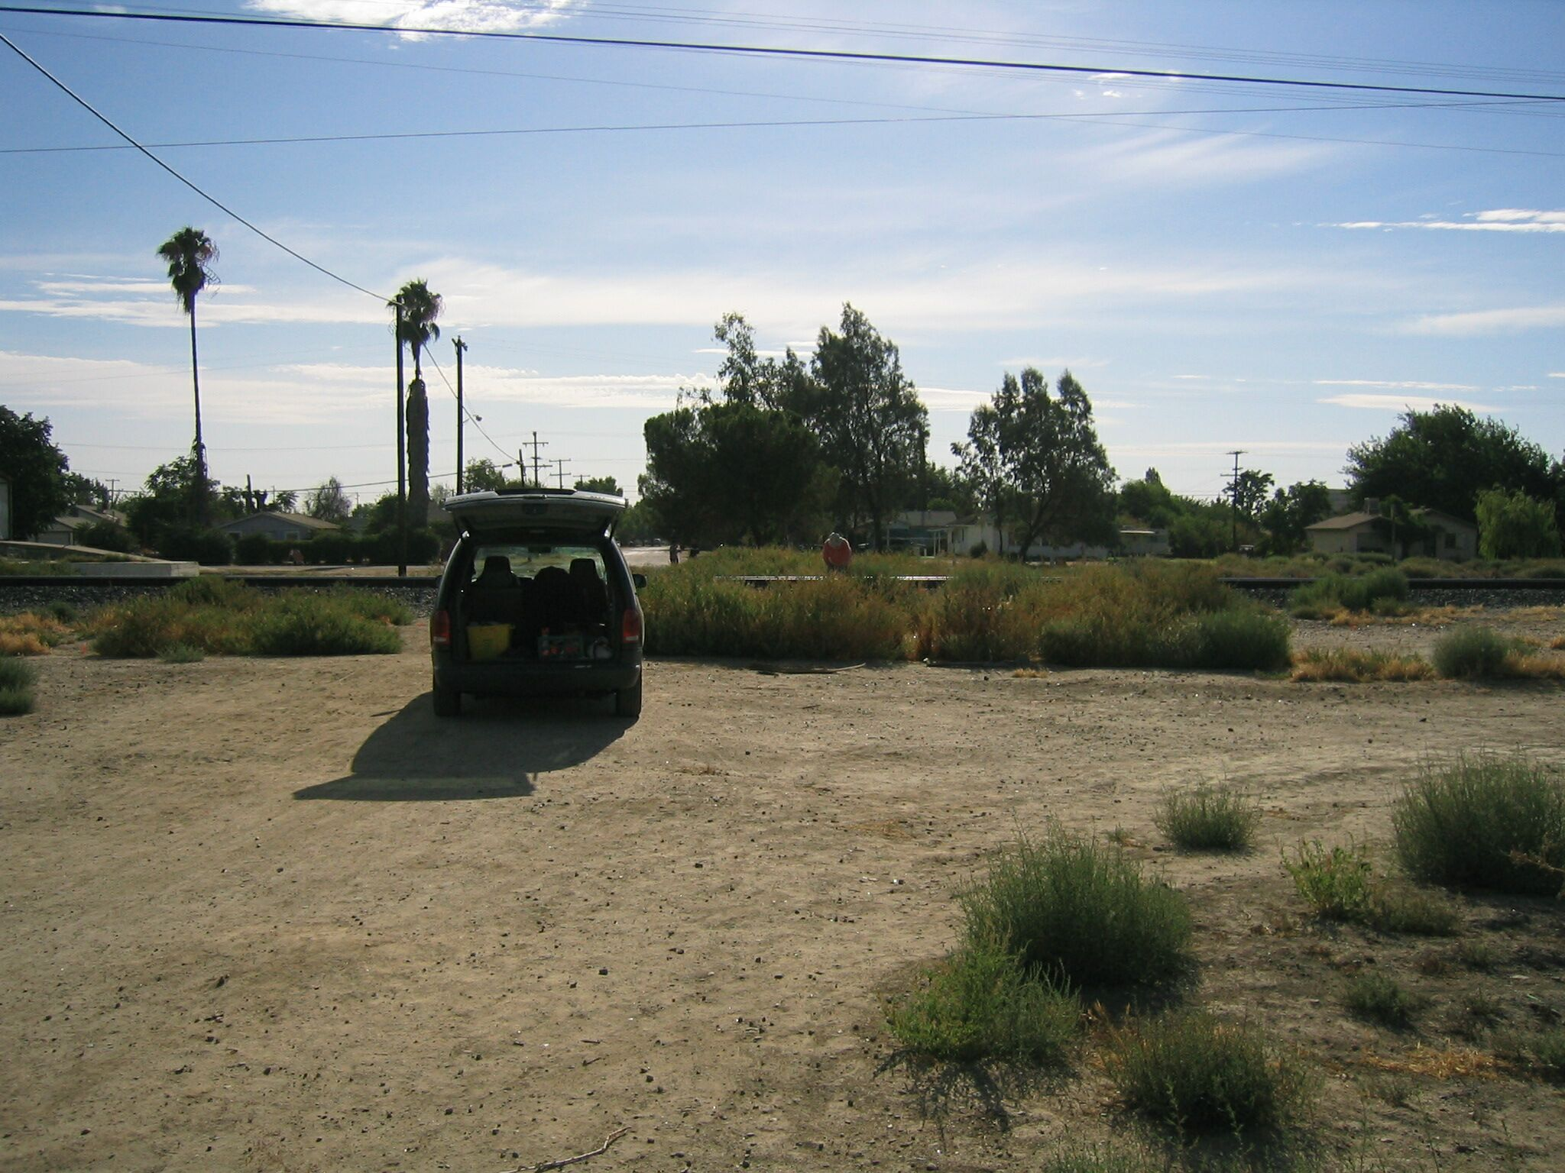
Mon

