DESIGNATION - HPGN D CA 06 FH
PID - AC6119

N 35 30 00.8

W 119 32 08.3

Recovered as described 07-30-2003

Additional recovery notes:
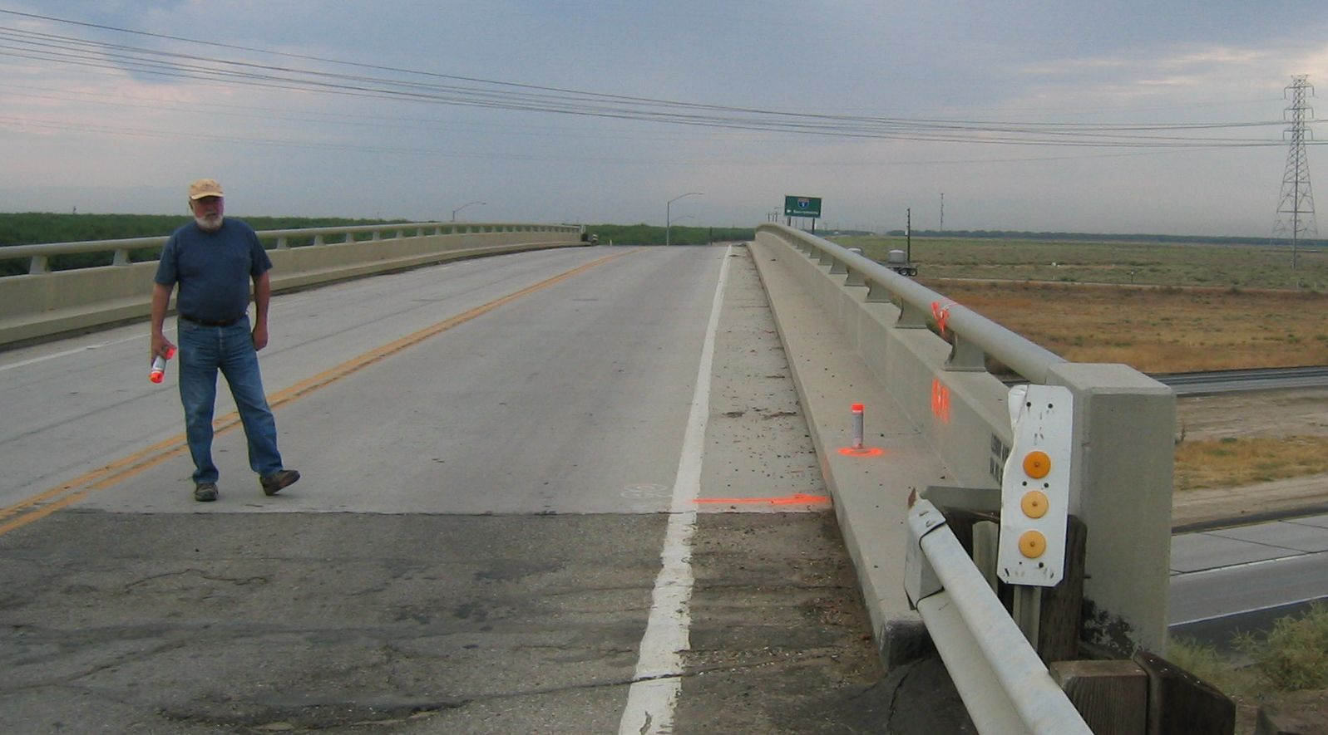
MON

