DESIGNATION - HPGN D CA 06 13
PID - FU3790

N 35 49 08.6

W 119 15 32.4

Recovered as described

Additional recovery notes:
Needs new witness post
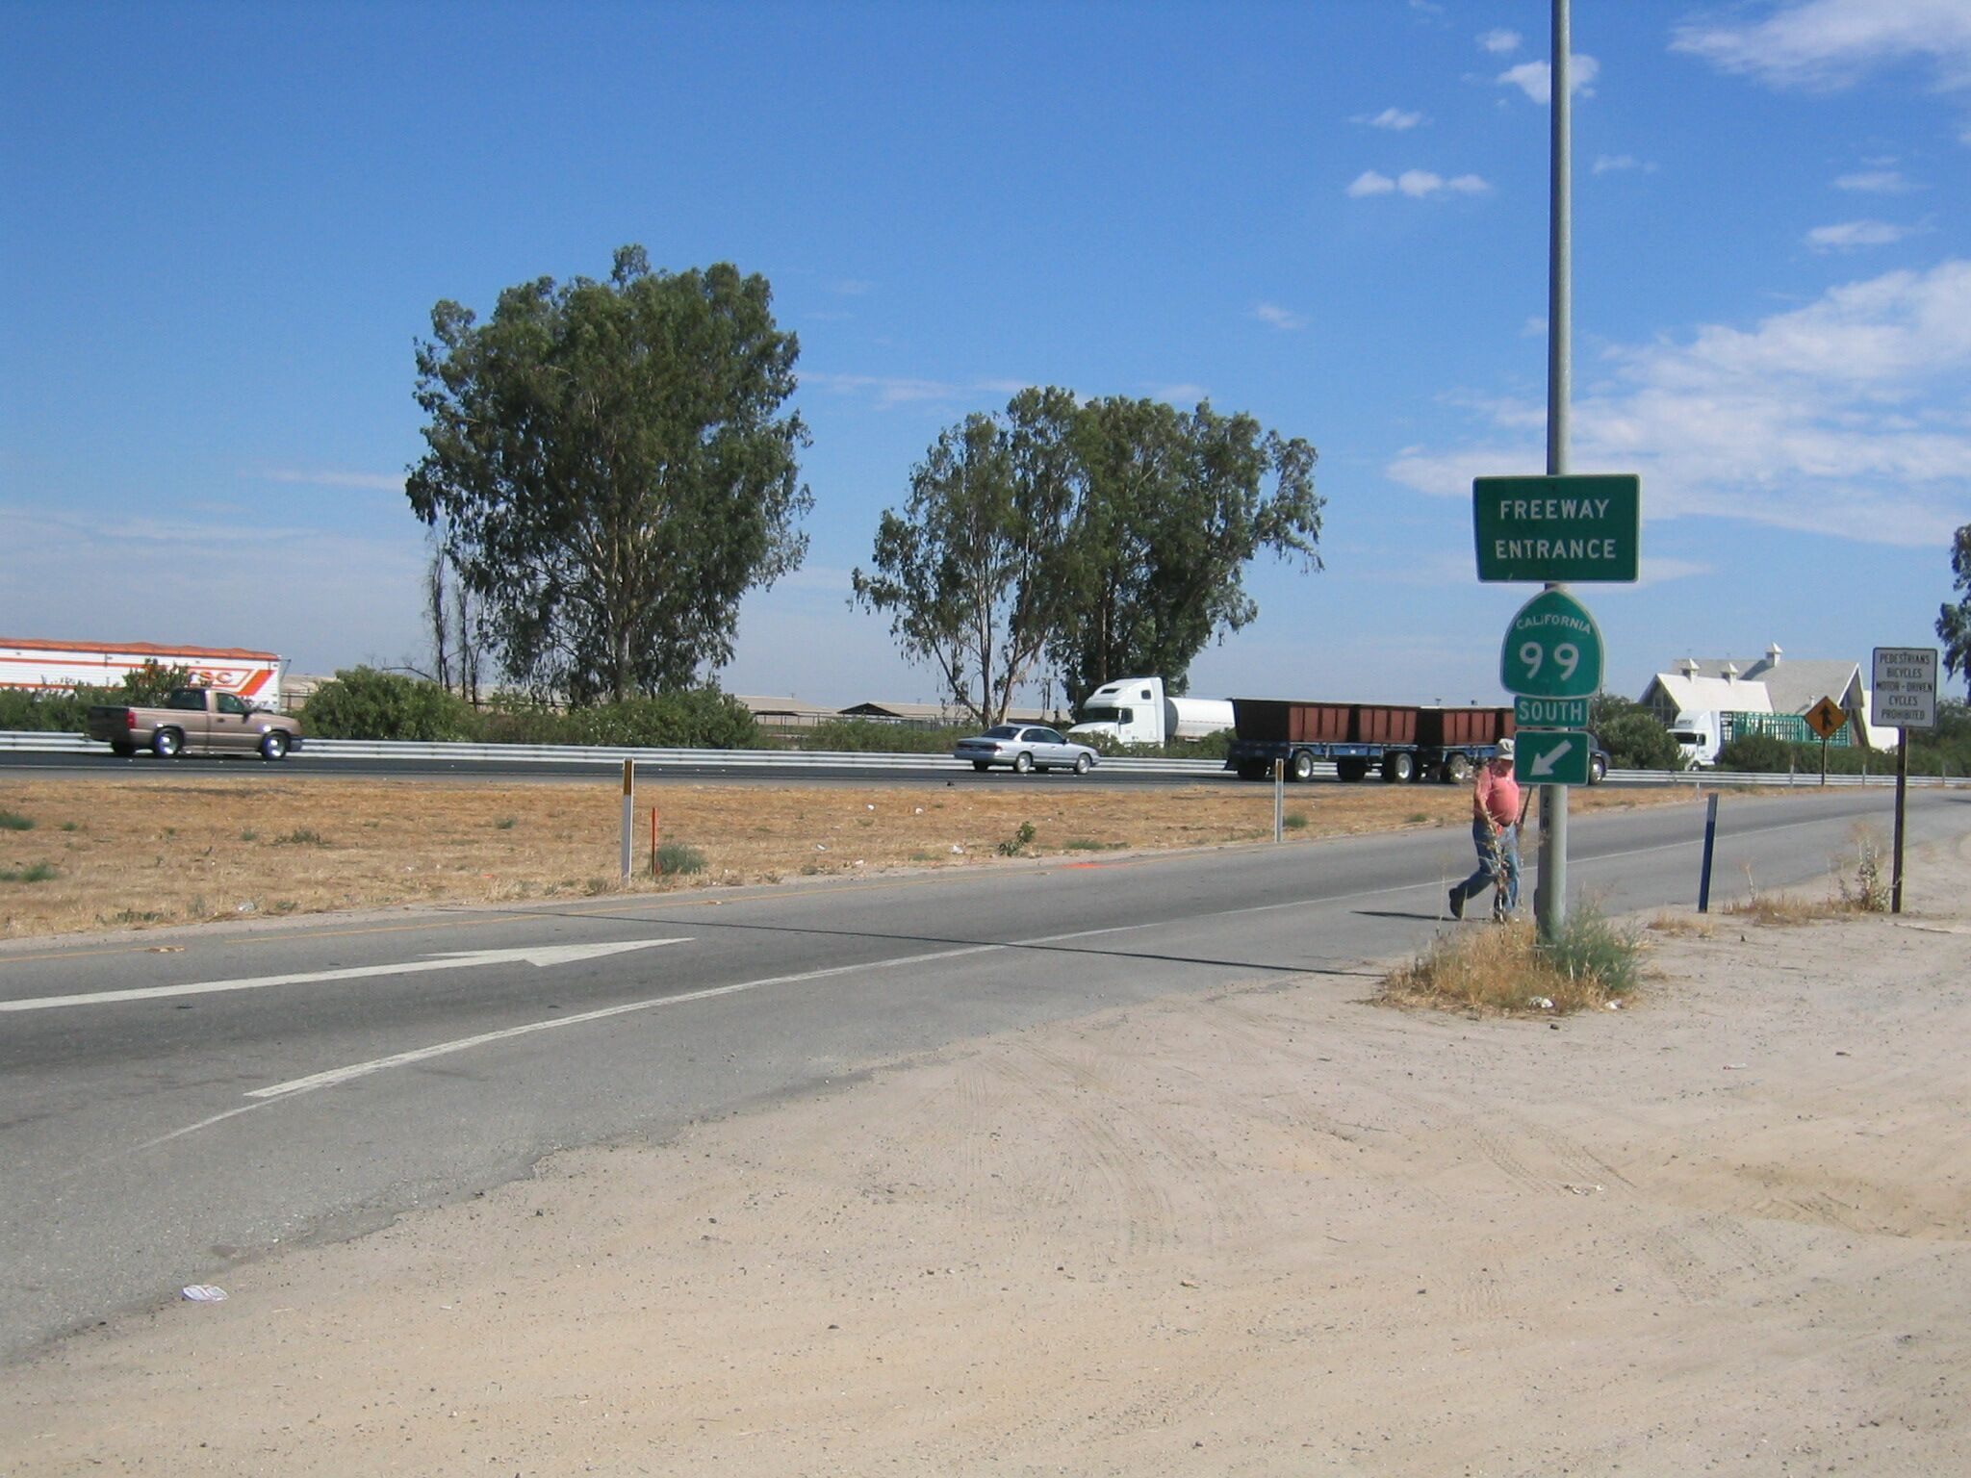
Mon

