DESIGNATION - HPGN CA
PID - HS0903

N 37 05 04.1

W 120 13 39.1

Recovered as described

Additional recovery notes:
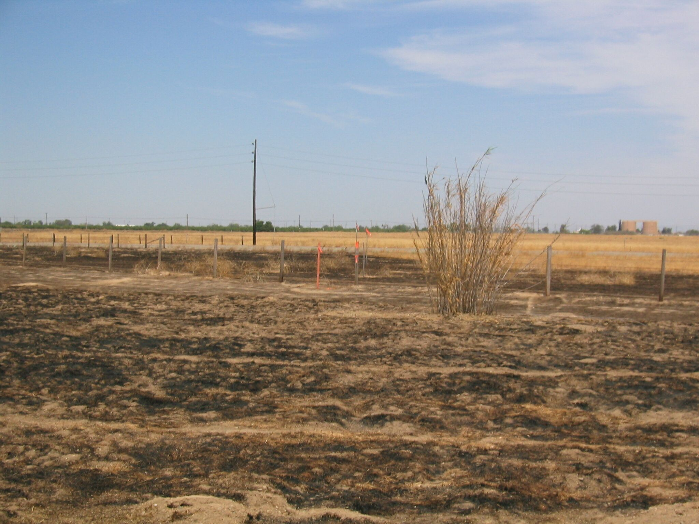
Mon

