DESIGNATION - HERRING
PID - NONE, SET NEW MONUMENT

N 35 08 55.8

W 118 59 44.0

Set new monument

Additional recovery notes:
To reach from the Herring Rd. Exit on Hwy 99. From the intersection of Herring Rd and Hwy 99 go east and south 0.1mi towards the on ramp to Hwy 99 northbound and the station on the right at a canal crossing. Located north northwest of the C/L of Herring Rd. Northeast of the southwest end of canal wing wall and southwest of an angle point in the head wall.

8.5ft from south end of wing wall
9.0ft from angle point in wall
40.0ft west of C/L of Herring Rd.
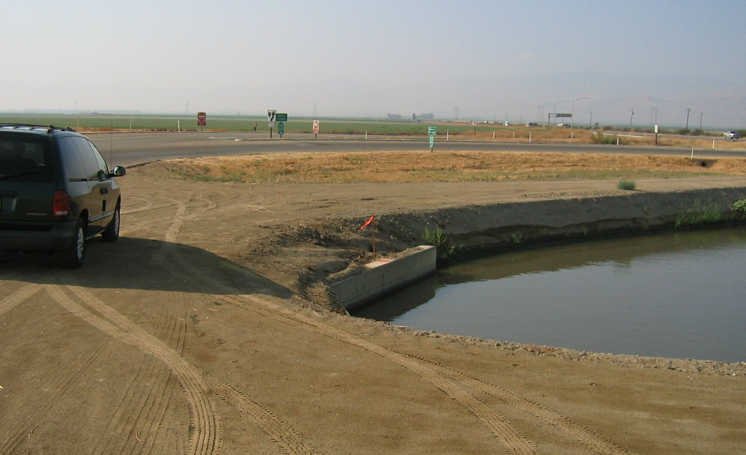
Set new monument

