DESIGNATION - H 512 RESET 1955
PID - GU1426

N 36 10 51.4

W 120 12 38.7

RECOVERED AS DESCRIBED 07-28-2003

Additional recovery notes:

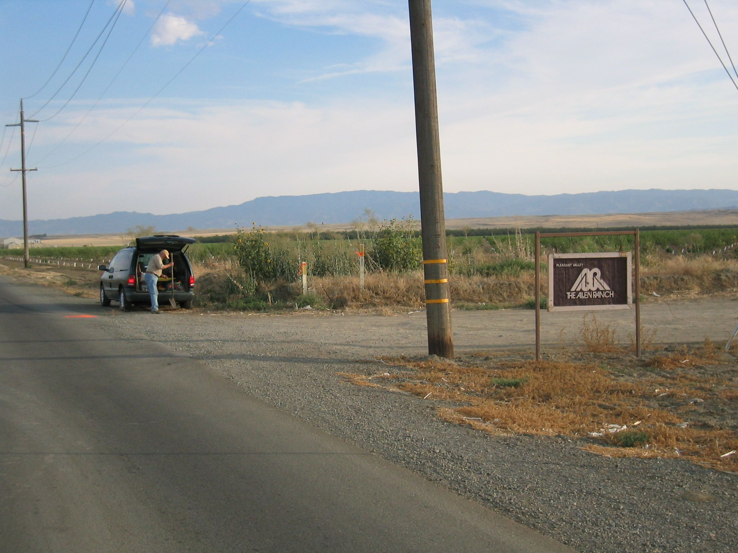
MON

