DESIGNATION - G 1445
PID - FU3753

N 35 59 33.6

W 119 57 33.7

Recovered as described, 7-29-2003

Additional recovery notes:

Need NGS Rod Adapter for GPS tripod.

To reach from Hwy 41 underpass at I-5 go north on Hwy 41 0.8mi to the California aqueduct and the station on the right.

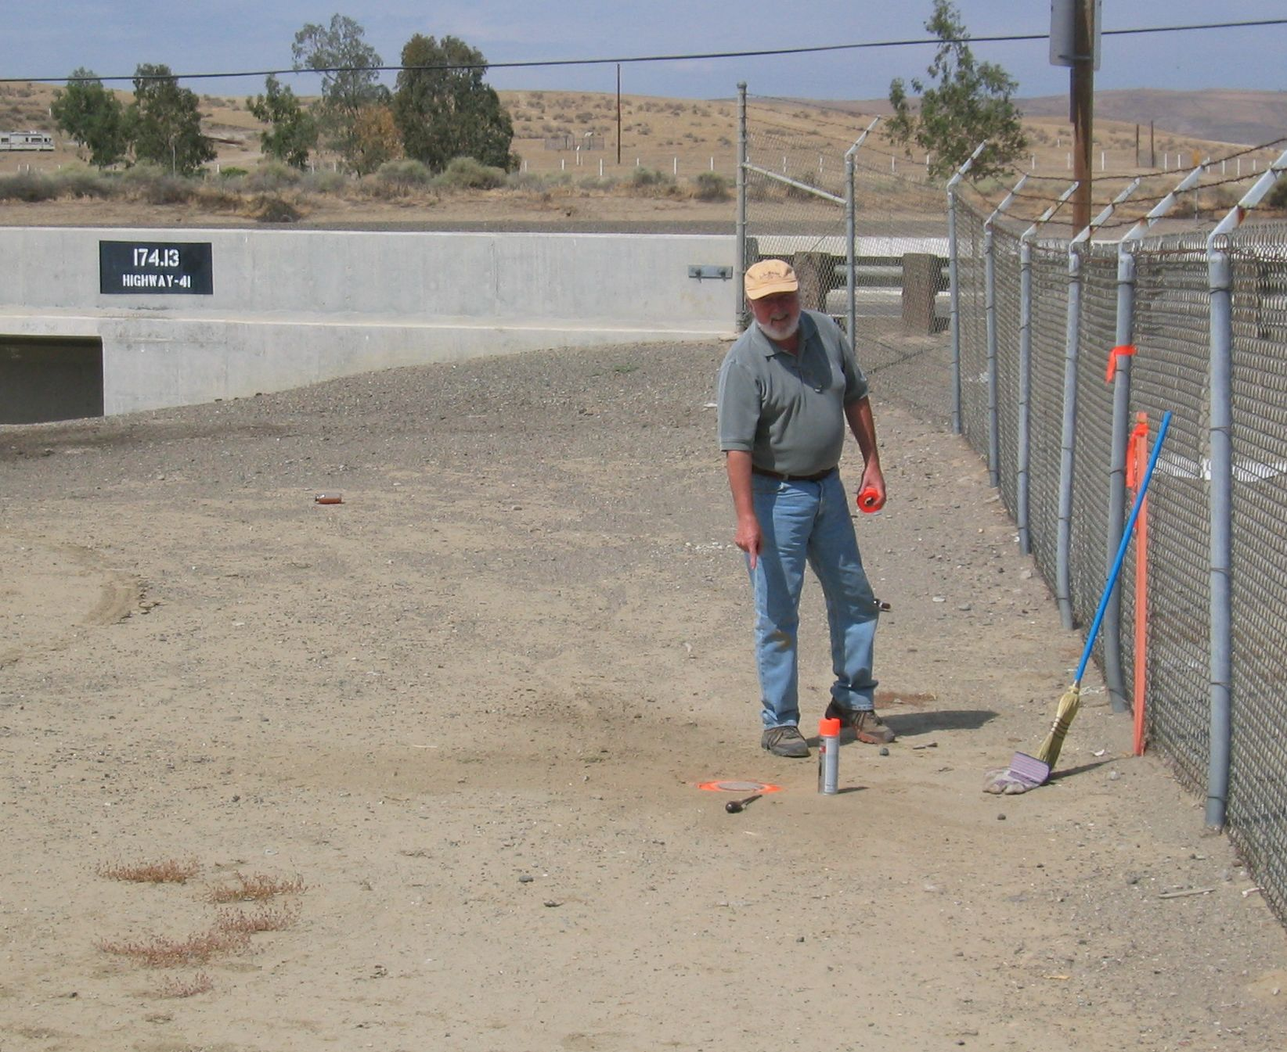
Note station is 15.5 ft east of pedestrian access opening in Aqueduct chain link fence.

