DESIGNATION - DUDLEY
PID - none, set new monument

N 35 50 40.5

W 119 49 25.5

Set monument in concrete.

Additional recovery notes:
To reach from I-5 and Utica Ave interchange go west 0.1mi to 25th Ave a paved side road left. Turn left onto 25th Ave and go south 2.0mi to the California Aqueduct crossing. Continue south on 25th Ave. 3.4mi to a paved side road left and the entrance to Paramount Farms. Turn left (east) and go 1.3mi to the California Aqueduct. Cross the Aqueduct and turn right and go southeast on a dirt road (parallel to the aqueduct on the right) 0.8mi to a dirt road to the left at a power-line crossing. Go left (east) 0.4mi to a dirt road crossing. Continue east 3.0mi to I-5 and where the road bears right (southeast). Turn right and go southeast to a dirt side road left. Turn left (east) and go 0.1 mile to the bridge over I-5 and the station on the right.

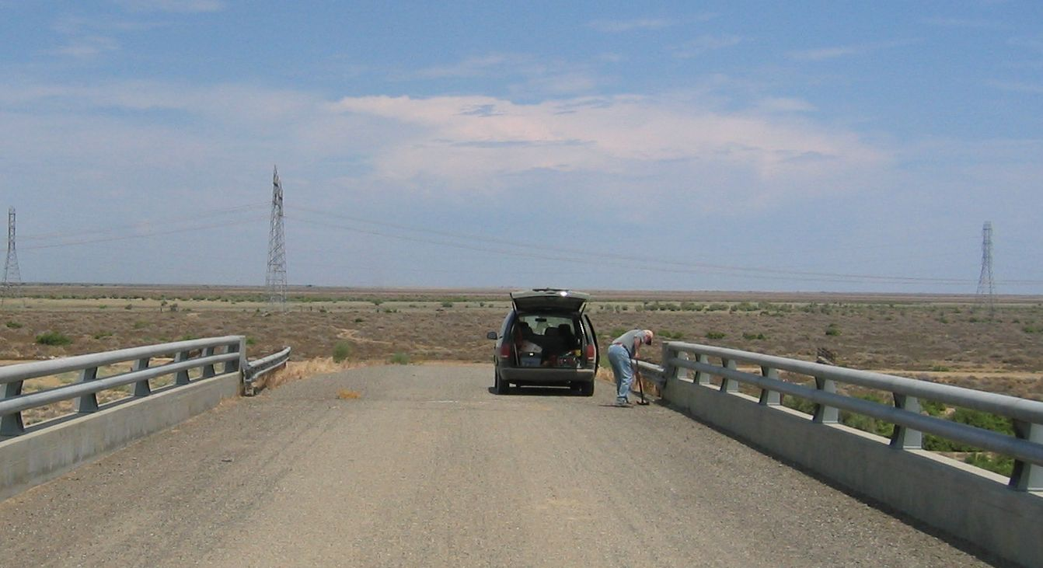
Station is at the east-end of the over-crossing, 11.0ft south of the C/L road, 1.0ft north from the south parapet face, 1.0ft west of the east-end of bridge deck.

