DESIGNATION - DRAIN
PID - none, New Monument

N 35 34 34.4

W 119 36 59.7

Set new monument in top of curb at abutment.

Additional recovery notes:

Station is located on the Main Drain Rd and I-5 overpass.
Station is 14.5ft east of C/L Main Drain Rd.
1.0ft south of the north end of the north abutment
1.0ft east from the west face of the east curb.

To reach from Hwy 46 and I-5 exit. From the intersection of I-5 and Hwy 46 go east on Hwy 46 1.8mi to Main Drain Rd a side road right. Turn Right (south) and go 2.8mi to the Main Drain Rd and I-5 overpass and the station on the left.
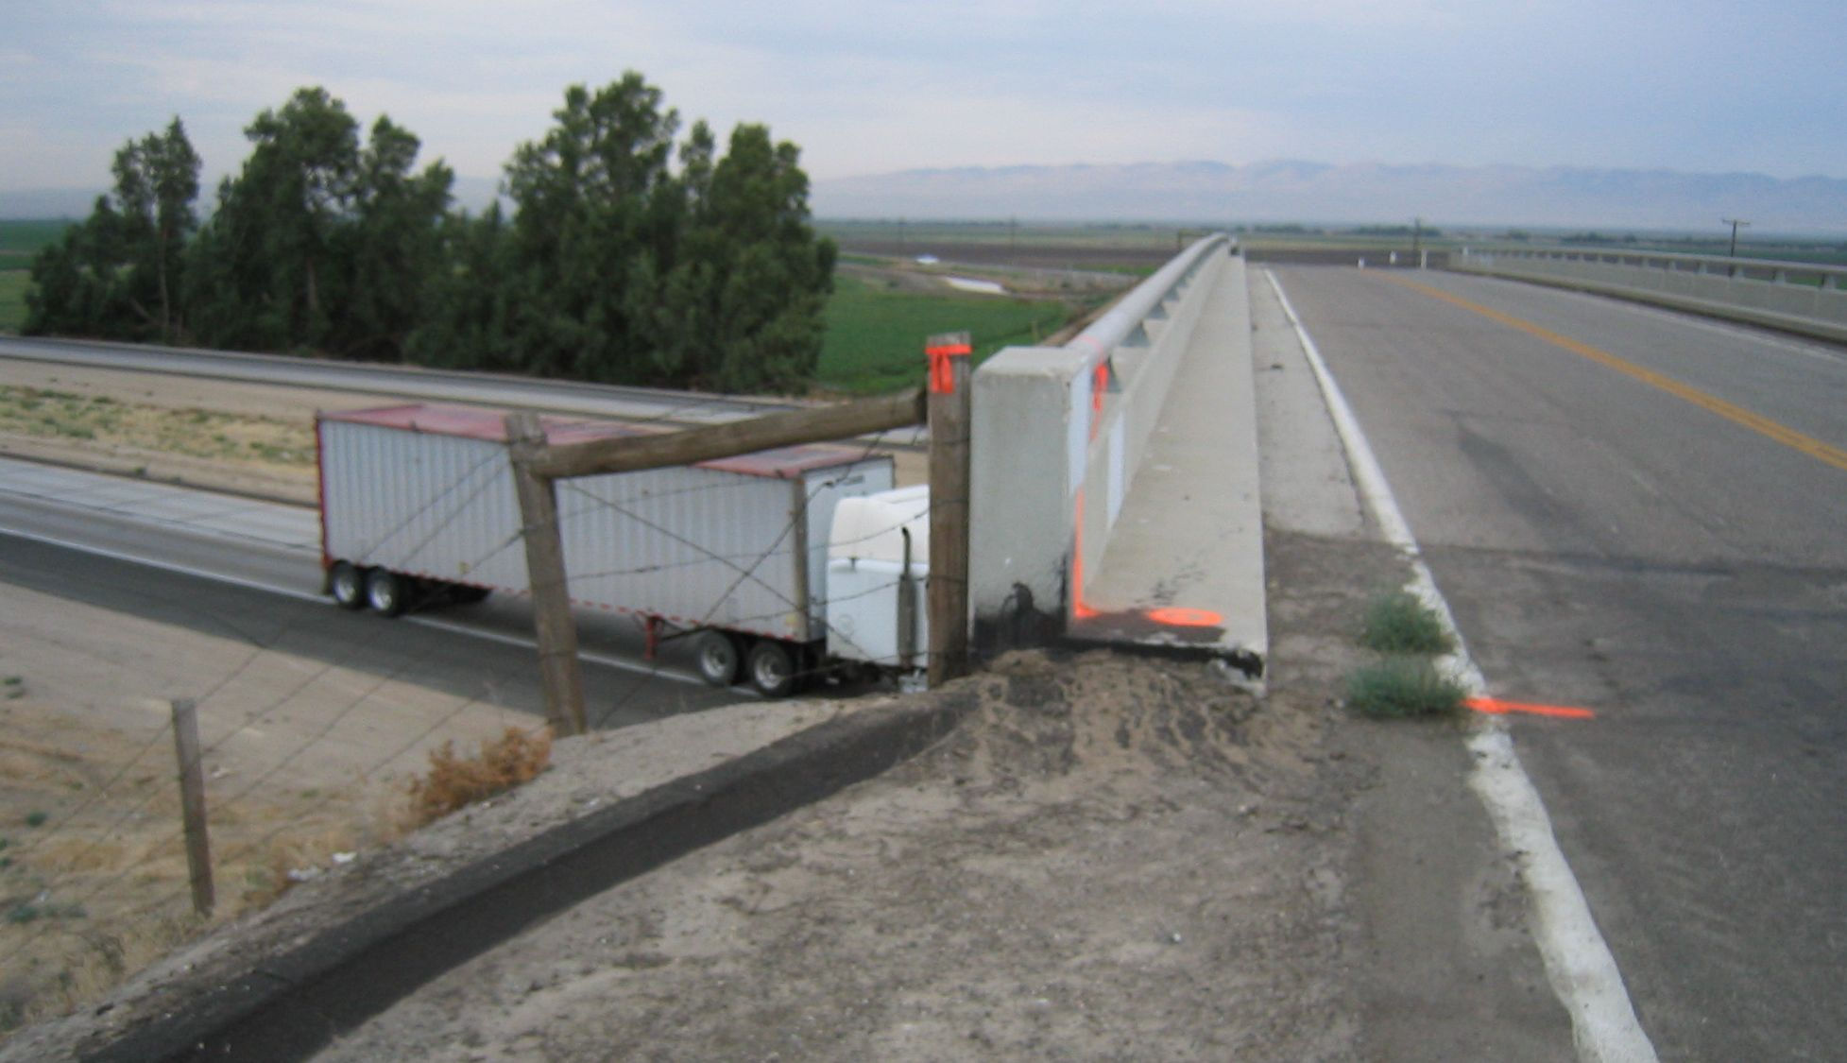
MON

