DESIGNATION - CUTOFF
PID - NONE, NEW MONUMENT

N 36 15 19.4

W 119 52 09.5

Set new monument on concrete bridge abutment in pedestrian sidewalk.

Additional recovery notes:
Station is located approximately 5 miles west of Lemoore near the Lemoore Navel Air Station. Station is located at the Avenal Cutoff Rd exit from Hwy 198 at the southeast corner the Avenal Cutoff Rd. overpass. Set monument in pedestrian sidewalk 25.6 feet east of the C/L of Avenal Cutoff Rd. and 2.5 feet north of south end of sidewalk.
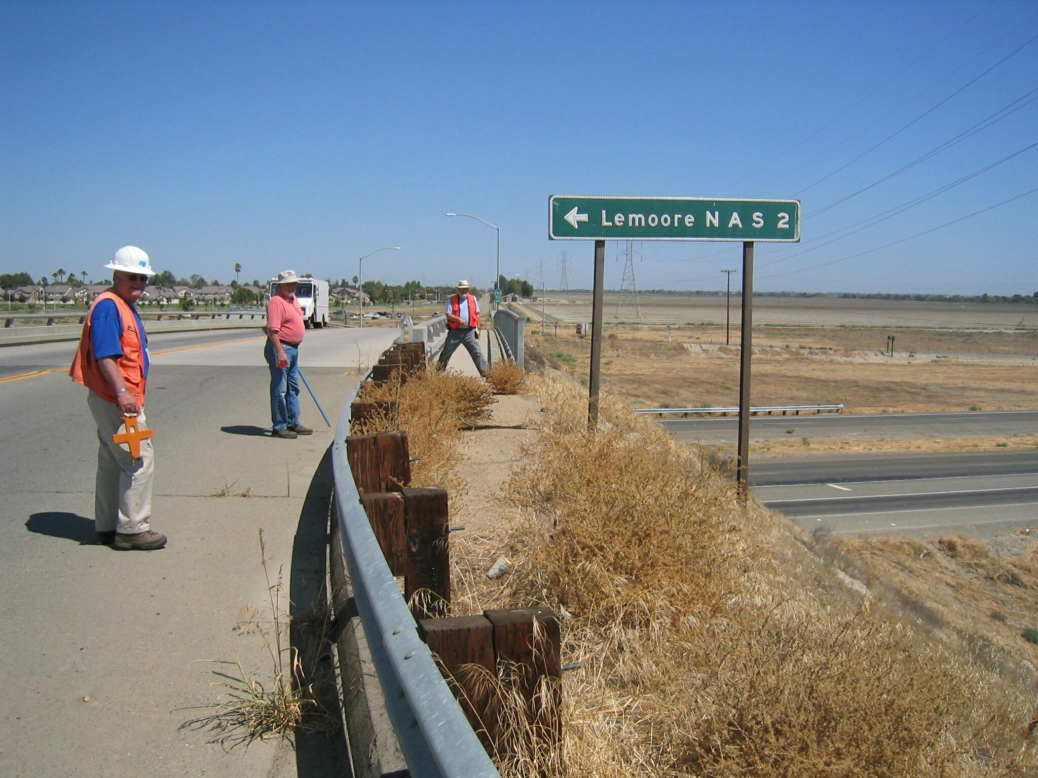
Mon

