DESIGNATION - COTTON
PID - NONE, SET NEW MONUMENT

N 36 55 24.9

W 120 01 11.8

Set new monument in concrete overpass.

Additional recovery notes:
Station is near Hwy 99 about 4 miles southeast of Madera.

To reach from Madera go southeast on Hwy 99 about 4 miles to the Avenue 12 exit. From the intersection of Avenue 12 and Hwy 99 go 0.1 mile east across bridge over the Union Pacific Rail Road to a side road left (Road 29) and the station on the right.

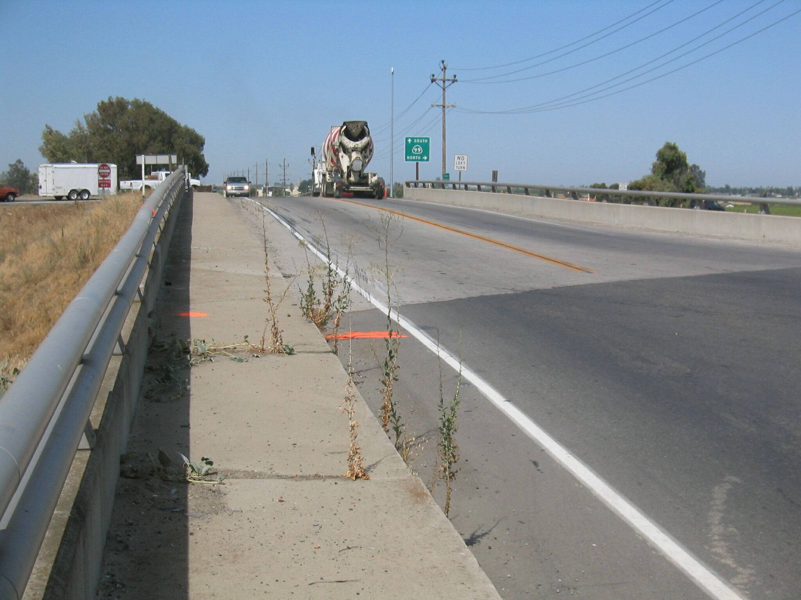
Set new monument in pedestrian crosswalk at the southeast corner of the Railroad overcrossing 20.0 feet south of C/L Avenue 12, and 15.0 feet east of the extended C/L of Road 29.
Set new
Monument

