DESIGNATION - COSTAMANGNA
PID - NONE, SET NEW MONUMENT

N 36 15 21.7

W 119 56 27.1

Set new monument in top of 3-ft diameter concrete irrigation standpipe and metering station.

Additional recovery notes:
Station is located on Hwy 198 approximately 9 miles west-southwest of Lemoore near the southwest corner of the Lemoore Navel Air Station.
To Reach from the intersection of Avenal Cutoff Rd and Hwy 198 go west on Hwy 198 4 miles to a dirt side road right (north) and the station on the right. Dirt side road right is approximately 50 feet east of a paved side road left (south).
Place monument in top of 3 foot diameter concrete irrigation standpipe and metering station located 176.0 feet north of C/L Hwy 198, 23.0 feet east of C/L dirt side road and 44 feet north of the north most row extended of double row of Eucalyptus trees.
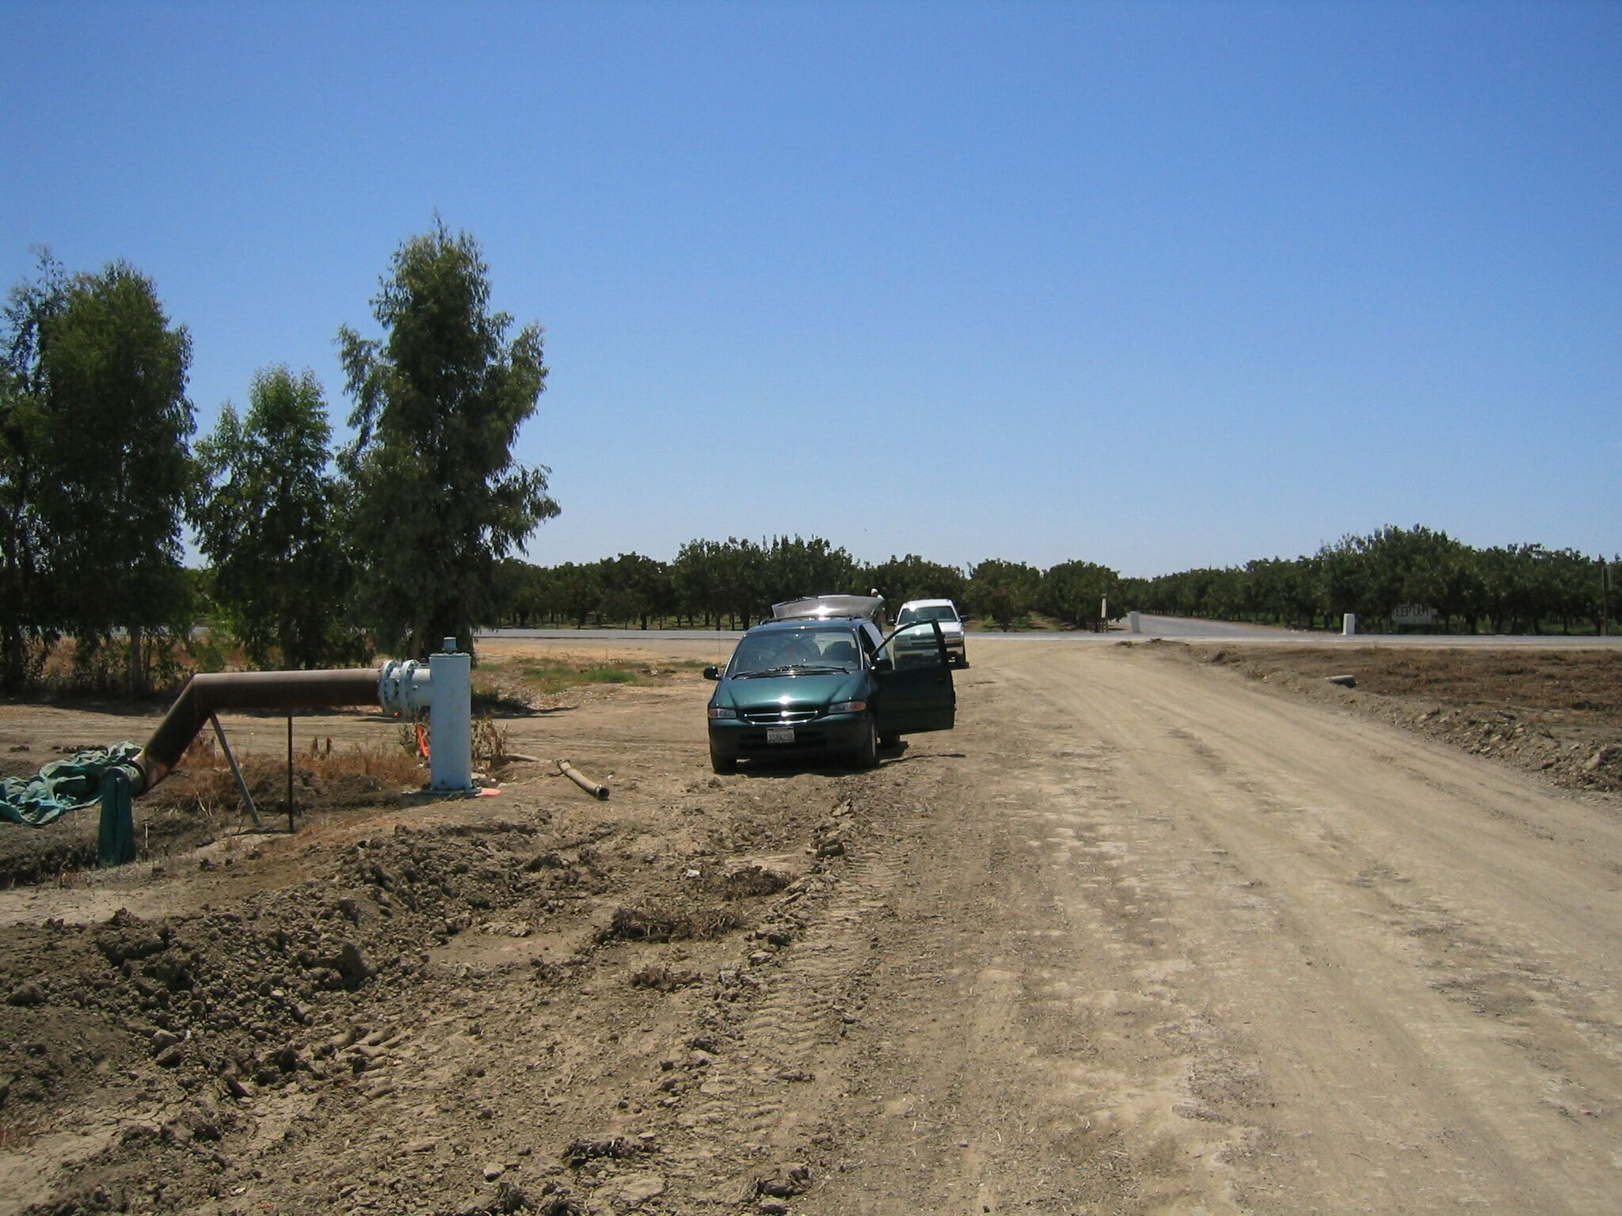
Set new
Monument

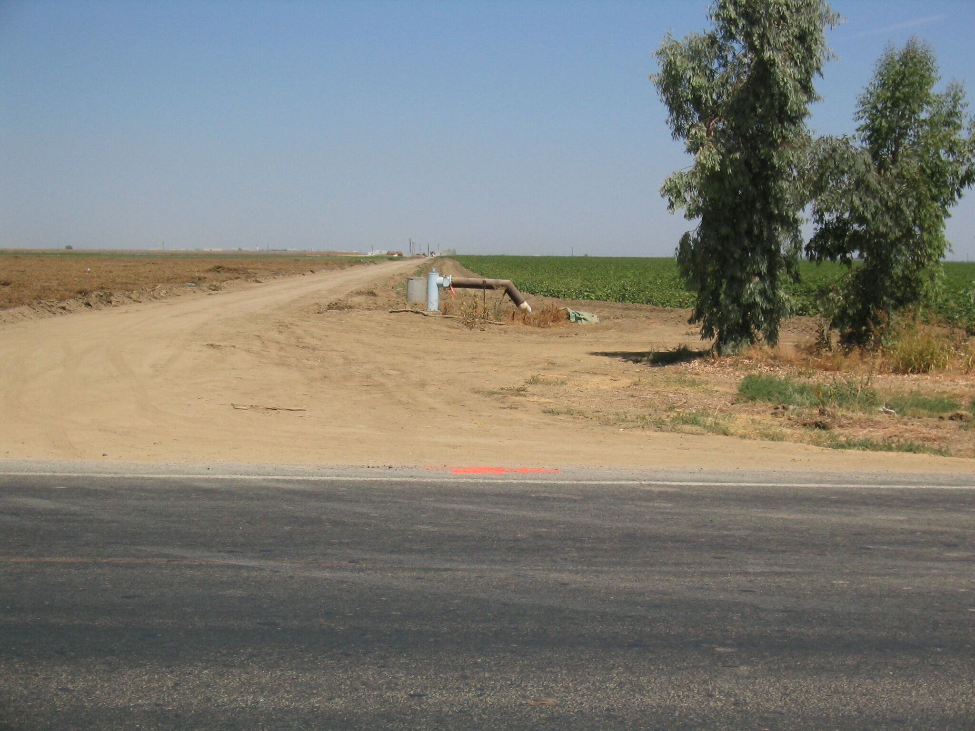
Set new
Monument

