SET NEW STATION

DESIGNATION - CLINE
PID - NONE, SET NEW STATION

N 36 33 13.9
W 120 31 04.9

Set new station on concrete bridge in top of curb.

Additional recovery notes:
Station is located on an overpass of Interstate 5 about 40 miles southeast of Los Banos. To reach from the Manning Ave. interchange at I-5 go east for 4.0 miles on Manning Ave. from the intersection to a dirt side road right (S Newcomb Ave.). Turn right and go south 3 miles to an orchard, continue south 0.5 miles to dirt side road right (sharp right). Turn right and go northwest 0.15 miles to bridge no. 42-244 crossing Interstate 5 and the station on the right.

Set monument on top of curb 1 foot northwest of southeast face of the northwest curb, 3 feet southwest of the northeast end of bridge abutment, 12.5 feet northwest of the c/l road, about 0.05 mile north east of the c/l of interstate highway 5, and 0.9 feet above road surface.

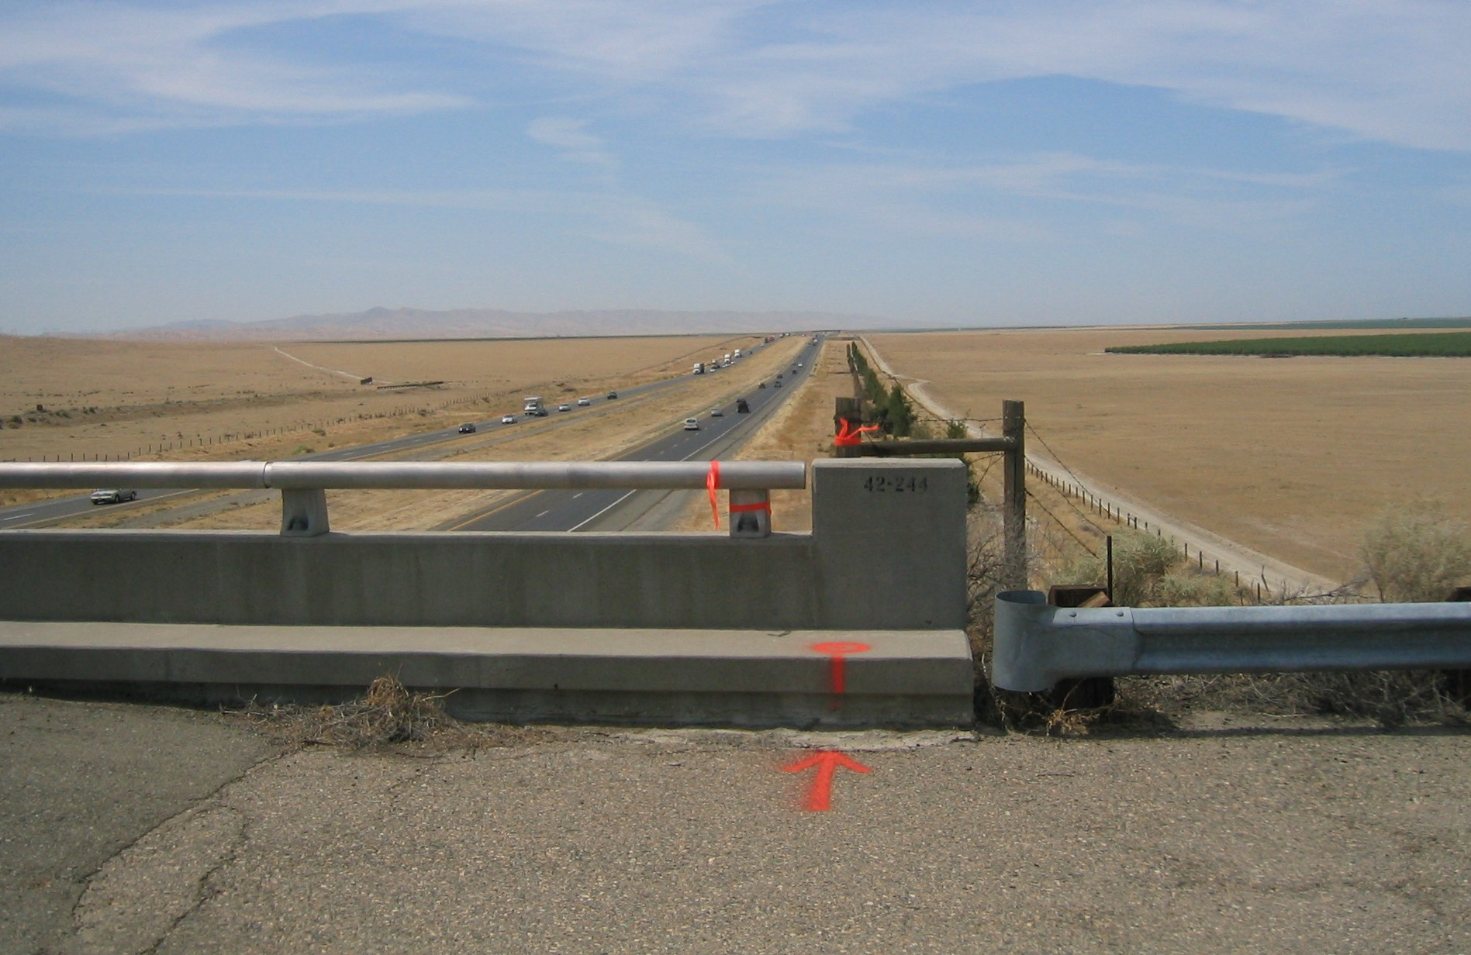
NORTH
SET
NEW
MON

