DESIGNATION - CAMP
PID - NONE, SET NEW STATION

N 36 20 08.9

W 119 24 37.8

Set new monument in top of concrete wing wall over creek.

Additional recovery notes:
Station is located east of the Union Pacific Railroad line on the western outskirts of Visalia approximately 0.5mi north of the Hwy 99 and Hwy 198 interchange.

To reach from the Hwy 99 and Hwy 198 interchange go north on Hwy 99 approximately 2 miles to the Betty Drive exit. From the intersection of Betty Drive and Hwy 99 go northeast on Betty Dr. 0.3 miles to Elder Dr to the east. Go east on Elder Dr. 0.1 miles to the intersection with Effie Dr to the southeast. Turn right onto Effie Dr and go 0.7 miles keeping left at the fork and running parallel to the rail road tracks on the left to a T intersection at Road 304. Turn left (east) and go 0.1 miles crossing the railroad tracks to Camp Dr. on the right. Turn right (southeast) and go 0.5 miles to Mill Creek and the station on the right.

Set new monument in top of Concrete wing wall at the southwest corner of the Mill Creek box culvert located 62 feet east of the east rail, 14.0 feet west of the C/L of Camp Dr. and 27.5 feet northeast of a railroad telegraph pole.

See photo next page.

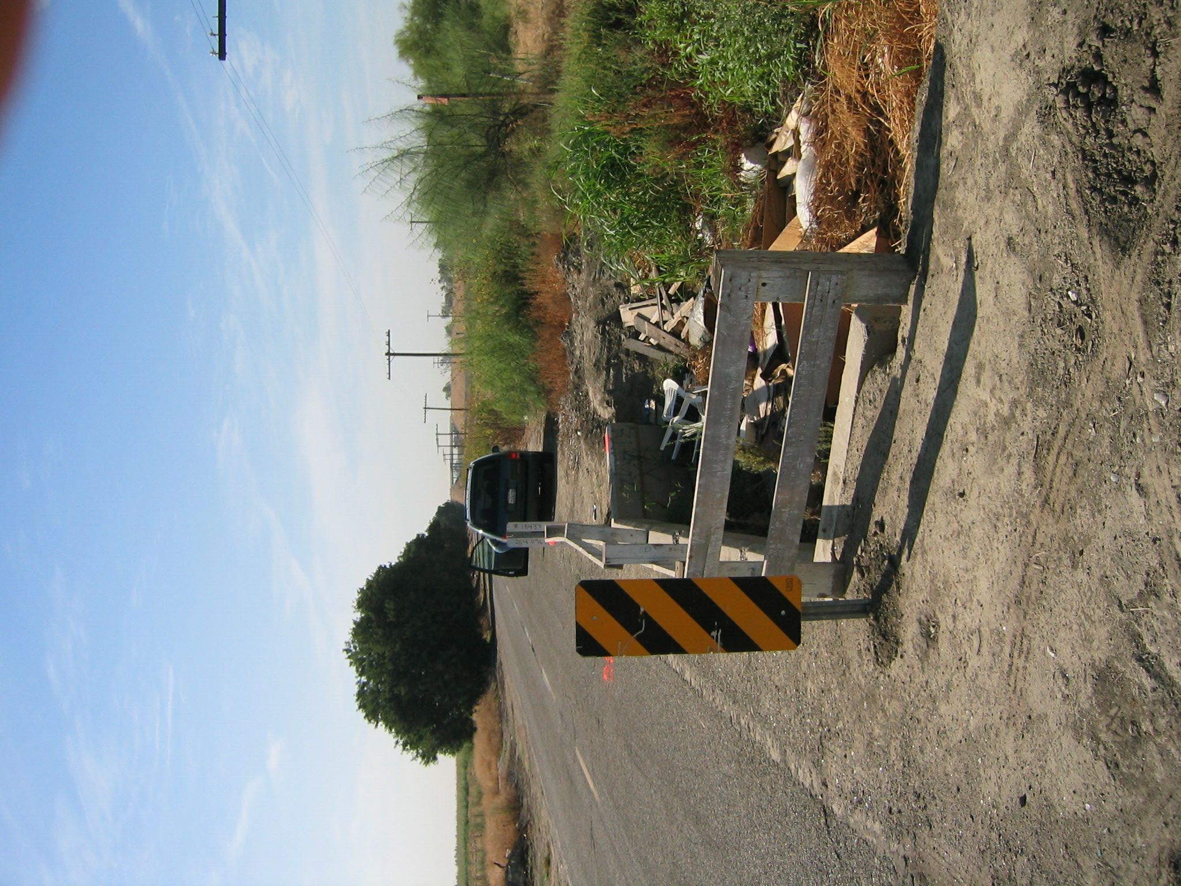
Set new
Monument

