DESIGNATION - BRANCH
PID - NONE, SET NEW MONUMENT

N 36 23 56.7

W 119 27 12.0 (15.0?)

Set new monument in top of concrete headwall of culvert.

Additional recovery notes:
Station is on the southwest side of Hwy 99, approximately 32 miles southeast of Fresno and about 6 miles north west of Visalia.

To reach from the intersection of Betty Dr. and Hwy 99 go southwest and south on Betty Drive and Diagonal 68 for 0.15 miles to a side road right (Avenue 308). Turn right (west) onto Avenue 308 and go 0.7 miles to a crossroad (Road 60). Turn right (north) onto Road 60 and go 2.6 miles to where the road turns left (northwest) and becomes Drive 60. Continue to the northwest on Drive 60 for 1.7 miles and the station on the left.
Station is 125 feet +/- southwest of C/L Hwy 99, 21.2 feet southwest of C/L Drive 60,
9.3 feet northeast of a fence line, and 1.0 feet north of the south end of a culvert headwall.
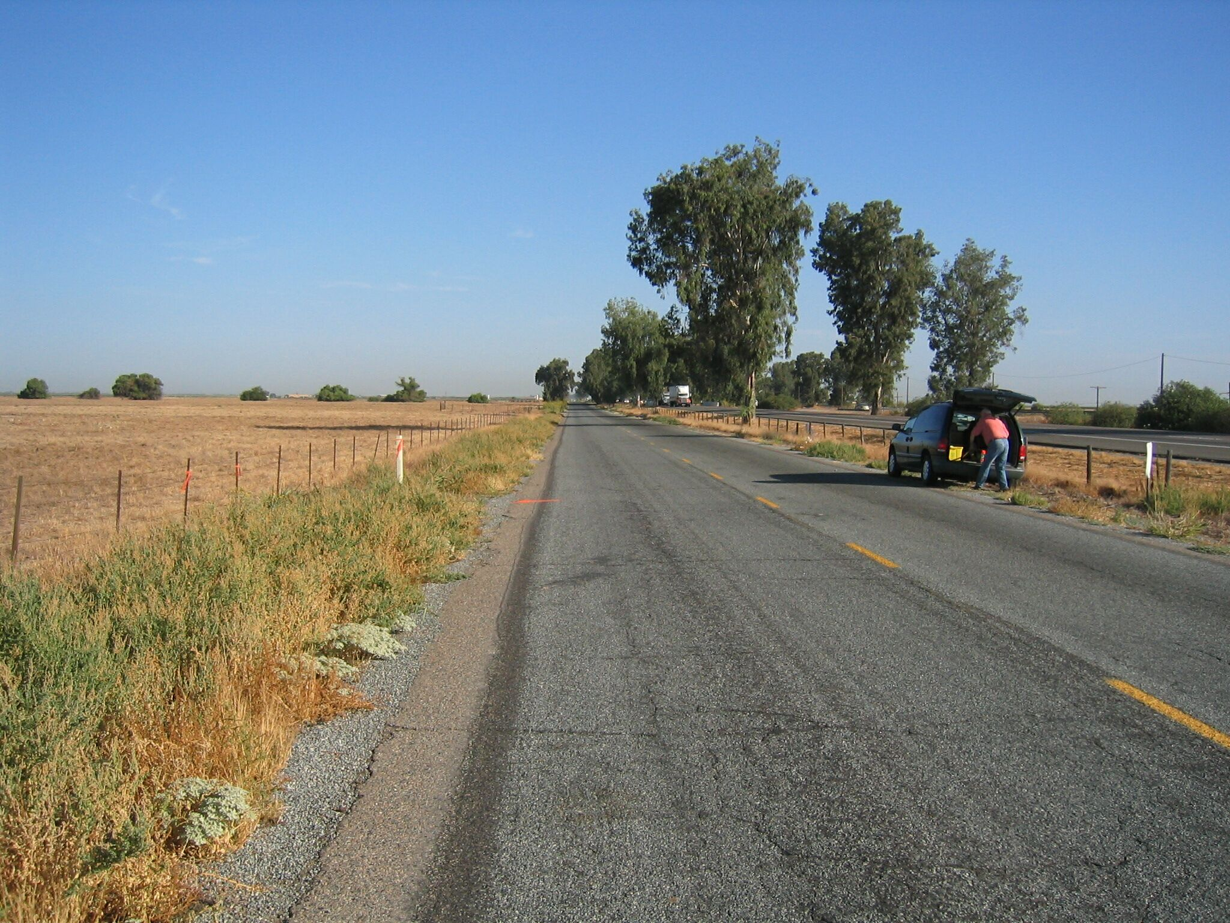
Set new
Monument
North

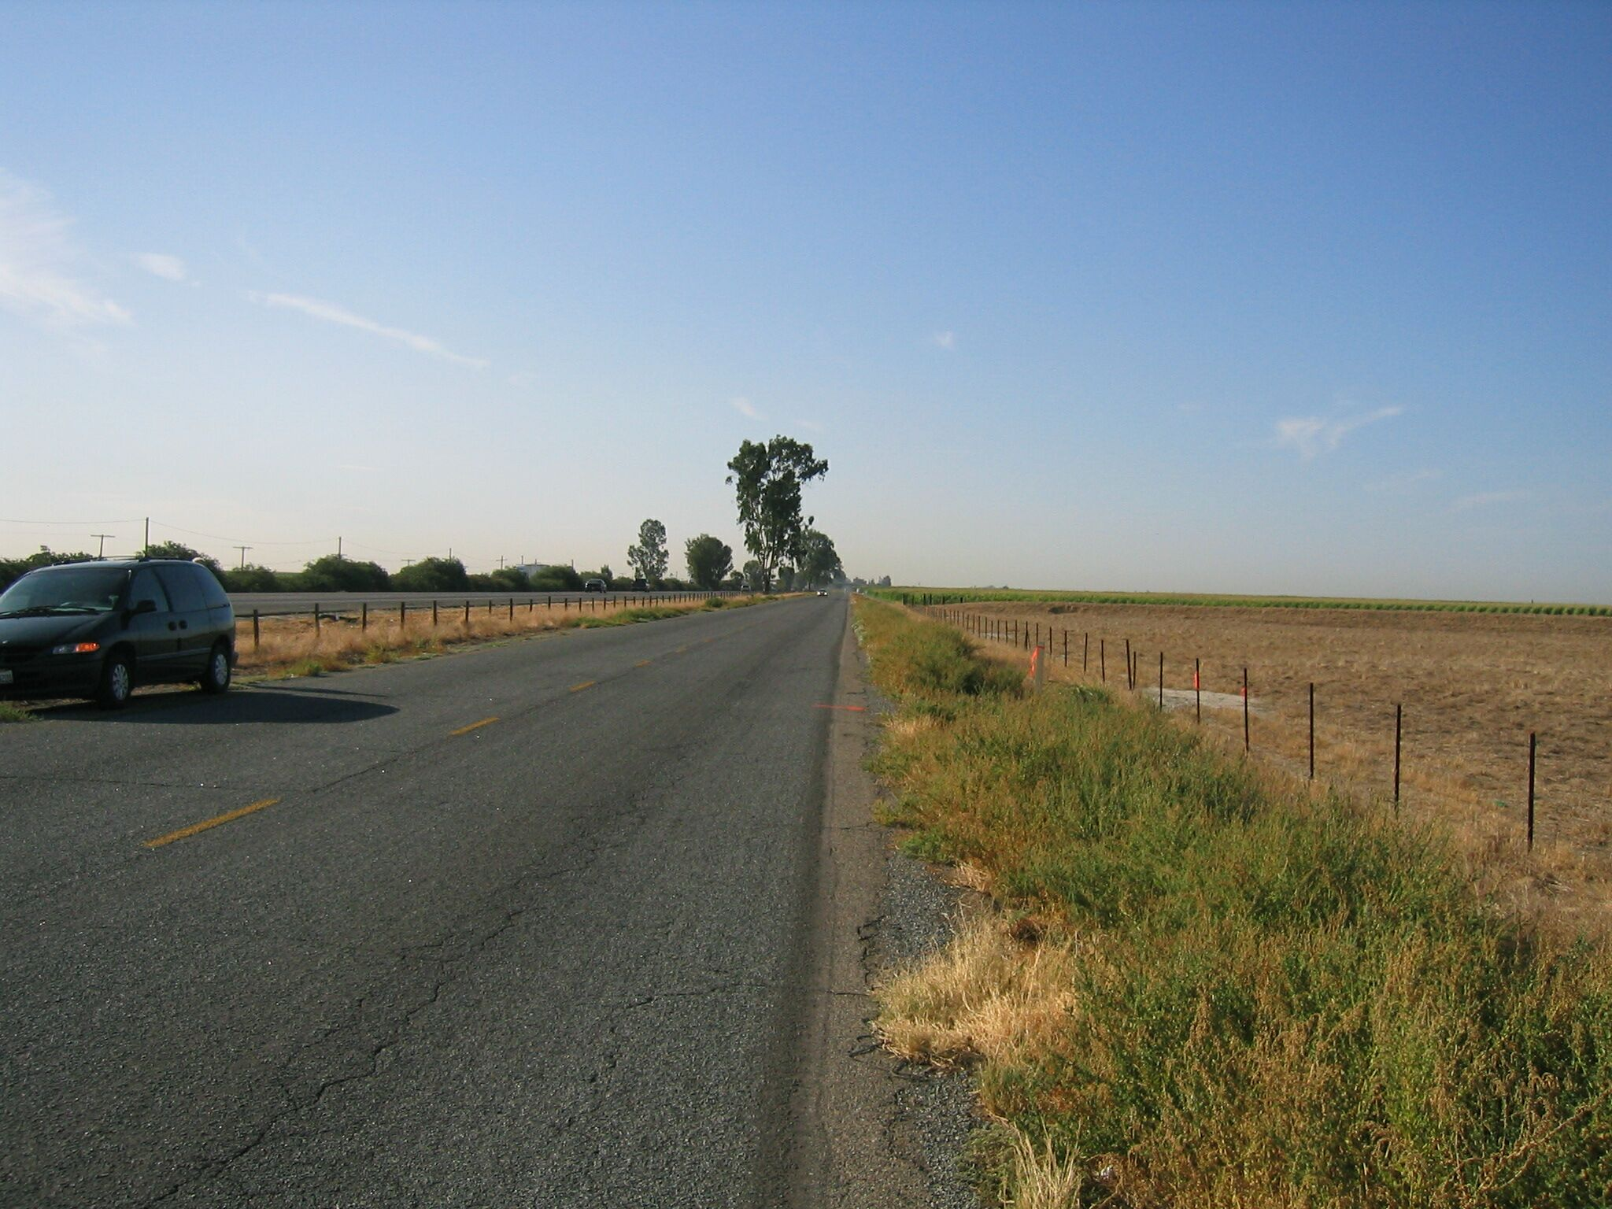
Set new
Monument
South

