DESIGNATION - 270.24 A
PID - NONE

N 35 04 01.2

W 119 07 54.8

Set new monument in concrete structure.

Additional recovery notes:
Station is located approximately 21 miles south-southeast from Bakersfield and about 19.2 miles southeast of Taft on the California Aqueduct near station 270.24.
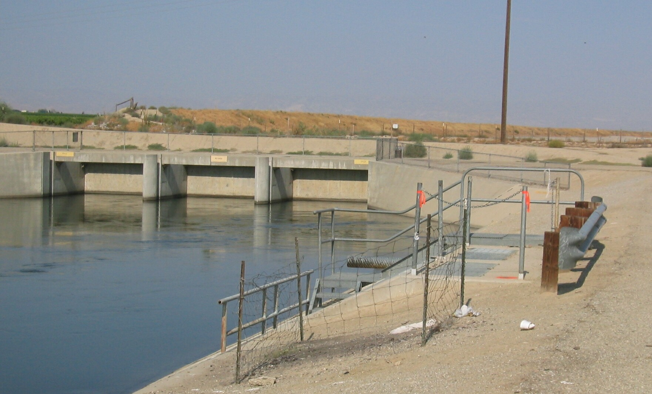
To reach from the Old River Rd. exit on Interstate 5, go south from the intersection on Old River Rd. for 4.7 miles to a crossroad (Copus Rd) where Old River Rd. turns to the southwest. Continue to the southwest on Old River Rd. for 2.3 miles to a dirt side road left located just prior to a California Aqueduct siphon and crossing. Turn left onto the frontage road to southeast and go about 300 feet (past a aqueduct pumping plant on the left) to a pedestrian access gate on the right. Go south through the pedestrian gate to the aqueduct and the station. Set the monument in the north east corner of an outlet structure located on the north bank of the canal, 12 feet south of the C/L of the north levee Rd., 1.2 feet south and 1.4 feet west of the northeast corner of the structure, and about 300 feet south east of the C/L of Old River Rd.
Set new
Monument

