DESIGNATION - 249.835
PID - HS1194

N 37 03 22.6

W 120 10 23.9

Recovered as described.

Additional recovery notes:
To reach from Ave. 20 (also Ave. 20 ½) intersection with Hwy 99 go east on Ave 20 for 0.15 to Fairmead Blvd. Turn left and go northeast 1.15 miles to the station on the left.

Station is located 46.8 feet east of east rail of the railroad tracts, 11.2 feet from a RR telegraph pole and 28.0 feet west of the C/L road.
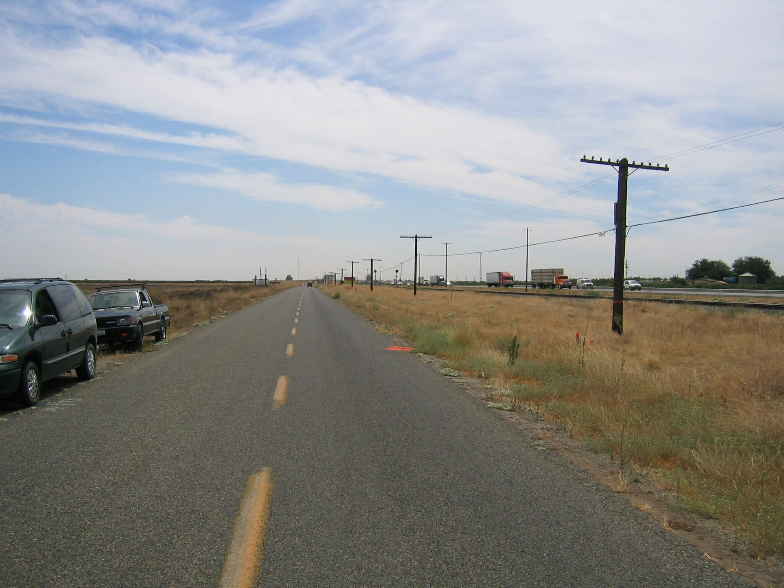
Mon

