DESIGNATION - 170.42 R
PID - GT0539

N 36 02 10.4

W 119 59 37.8

Recovered as described 7-29-2003.

Additional recovery notes:
Traffic control advised.

To reach from the intersection of I-5 and Hwy 41 go north on Hwy 41, for 3.8mi to Quail Ave a side road left. Turn left (west) and go 1.9mi to the California Aqueduct and the station on the left.

To reach from the intersection of I-5 and Lassen (Hwy 269) go south on Lassen 0.3mi to Avenal Cutoff Rd. a side road left. Turn left and go east and northeast for 0.5mi crossing I-5 to Plymouth Rd. to the Right. Turn right and continue east on Plymouth Rd. for 5.2mi to a crossroad at 30th Ave. Turn right on 30th Ave., go South for 2.5mi to a crossroad and Quail Ave on the left. Turn left on Quail Ave and go east for 0.5mi to the California Aqueduct and the station on the right.

Photo on next page.

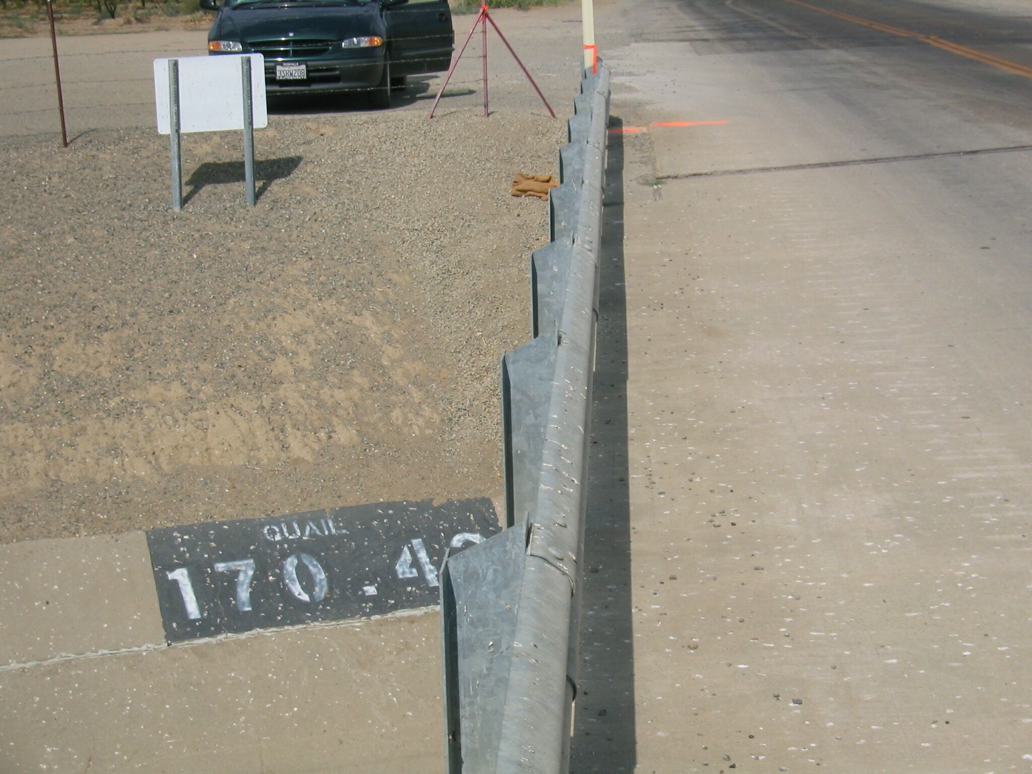
Mon

