DESIGNATION - 12193003 AVE.7 SLC
PID - NONE

N 36 51 06.2

W 119 56 43.1

Recovered California State Lands Commission brass plate (LS4343)

Additional recovery notes:
Located about 1.2 miles north of the San Joaquin River and about 10 miles southeast of Madera on the Avenue 7 bridge crossing the Union Pacific Rail Road tracks running parallel to Hwy 99 on its east side.
To reach from the intersection of Avenue 7 and Hwy 99 go east on Avenue 7 about 500 ft to the east end of the bridge crossing the Union Pacific Railroad tracts and the station on the left. Station is located in the pedestrian walk 18.5 feet north of the C/L road and 7.1 feet west of the east end of the bridge.
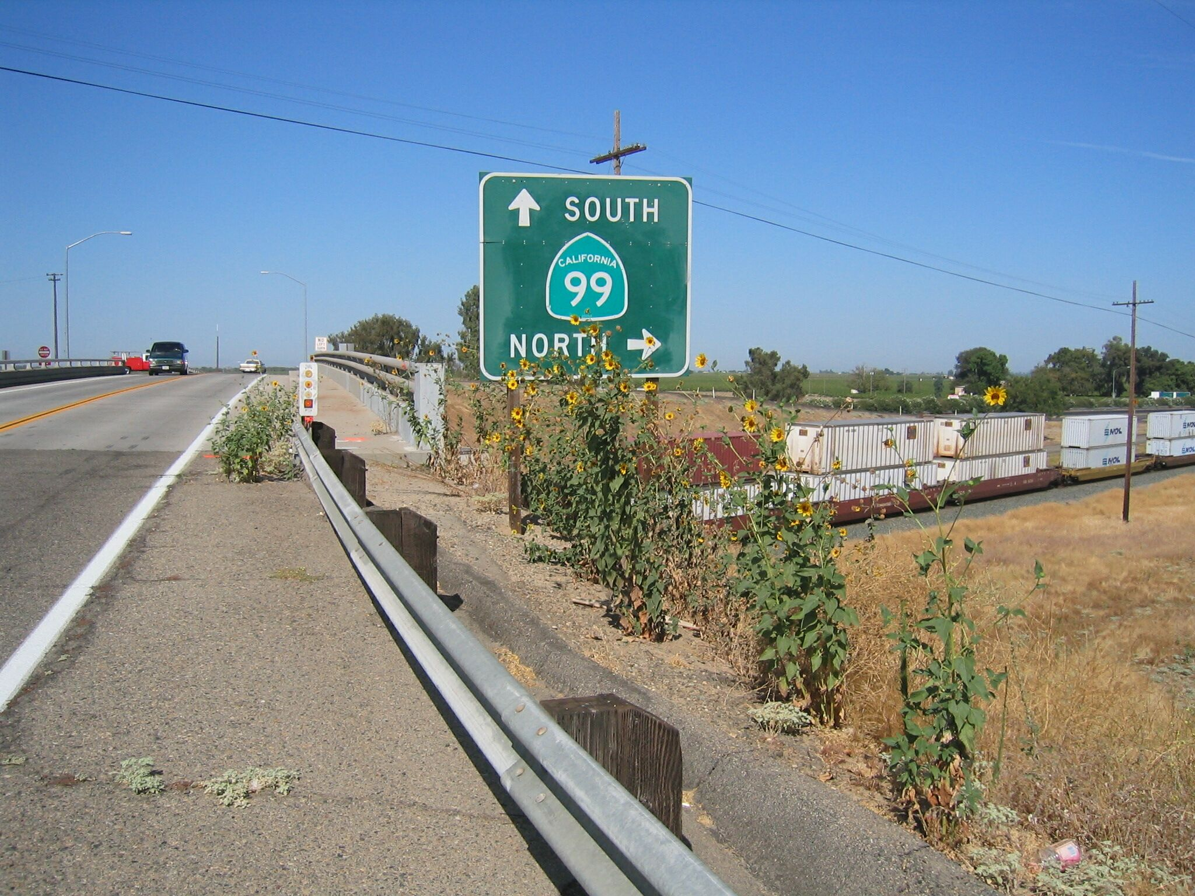
Mon

