Case Study 3: Yolo County Surveys (1999 and 2002)

***In progress – material below in early draft form***

Constrained adjustment – multiple projects

In this section we examine the two Yolo projects (1999 and 2002) for both horizontal and vertical movements. We use the former to provide an assessment of the current version of HTDP.

Horizontal movements. To analyze how well HTDP predicts horizontal movement in a typical California network, the Yolo County surveys were examined for changes in horizontal coordinates. First, the 1999 coordinates of the Yolo stations were precisely adjusted, using SECTOR-derived of-date coordinates for the CORS sites SUTB and UCD1 as constraints. Then, HTDP was applied to predict where the network stations would be after a period of 3 years. These computations were then compared against the precise adjusted coordinates from the 2002 survey, using again SECTOR-derived of-date coordinates for the CORS sites SUTB and UCD1 as constraints. The results of this comparison are shown graphically in Figure 1.

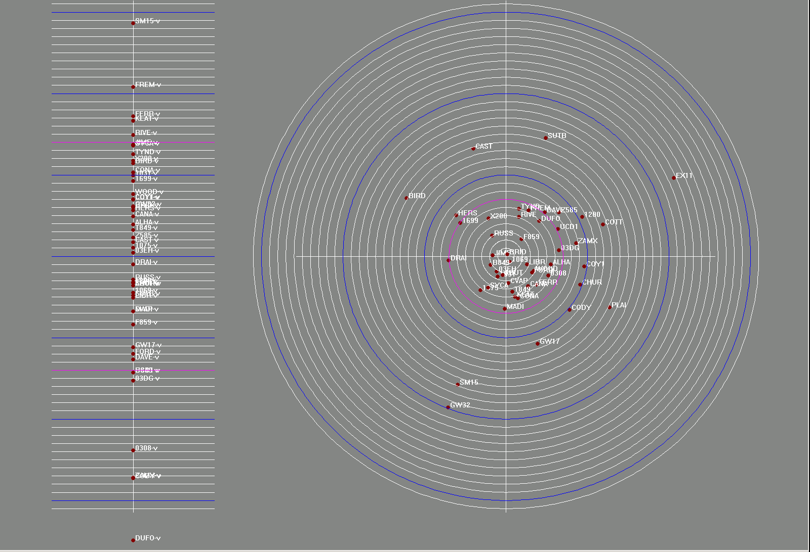
Figure 1: HTDP predictions versus surveyed results in Yolo County
In this illustration, changes in vertical coordinates versus the HTDP prediction are shown on the vertical scale on the left. The midpoint of the vertical scale represents the HTDP prediction (which of course was zero, because HTDP doesn’t predict vertical deformation), while the red dots along the vertical scale show the surveyed vertical displacements of the network passive stations. Each white line is 1 millimeter of movement; each blue line is 1 cm of movement, and the magenta lines represent the standard deviation (14 mm) of the differences between HTDP and surveyed heights. The only real news from this test was that some means in addition to HTDP must be devised to predict vertical deformation for passive stations.

The horizontal velocity analysis provided more concrete results concerning the usefulness of HTDP for predicting of-date coordinates for passive monuments. In Figure 12, the circular scale on the right represents the difference between HTDP-predicted horizontal coordinates for 2002 network stations and the surveyed coordinates from the 2002 survey. The center of the circle (center of the cross-hairs) represents the HTDP horizontal prediction for all points, while each red dot (with station name) represents the adjusted coordinates from the 2002 survey. Each white line is a millimeter, each blue line is a centimeter, and the magenta line is the standard deviation (7 mm) of differences in horizontal coordinates. The differences are clustered around the bull’s-eye, which is encouraging, but some of the differences are in the 2-cm range. In other words, the “actual” positions of these points are 2 cm different from where HTDP predicted they would be.

So this diagram is a diagram of network decay over time, even when a very good horizontal velocity model like HTDP is in use. Another illustration of the difference between HTDP and surveyed positions (representing the same data shown in Figure 1) is shown in Figure 2.

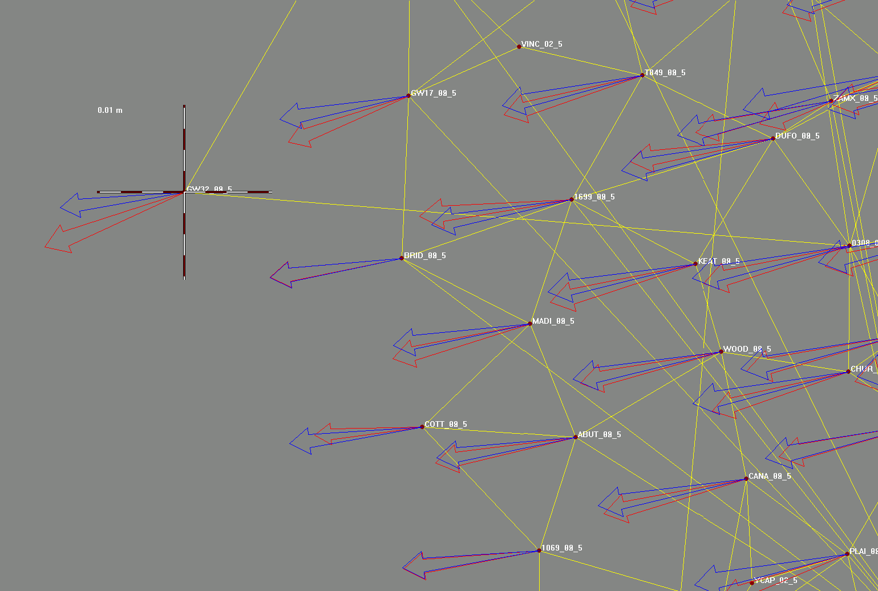
Figure 2: A portion of the Yolo Co. network showing HTDP and surveyed coordinates
This figure is an inset magnification of the westerly portion of the network. The red arrows represent surveyed displacements, and the blue arrows represent HTDP predictions. It is encouraging to see that HTDP generally does a good job of predicting the direction and magnitude of displacements, but the discouraging news is that the displacements are so large that even an apparently small difference (as represented graphically) still can represent 2 cm of difference, as is the case at the most westerly point, GW32.

Numerically, the effect of the network decay can be shown in the following chart. In this chart, the average standard error for adjusted horizontal and vertical coordinates is given for each epoch (1999 and 2002) and these can be compared against the formal errors for 2002 coordinates as predicted by HTDP:

Coordinates | ⬧ 1999 surveyed | ⬧ 2002 surveyed |  2002 HTDP
Horizontal | 2 mm | 2 mm | 7.2 mm
Vertical | 7 mm | 7 mm | 15.7 mm

It can be seen from these results that most of the error, by a great margin, in the HTDP-predicted coordinates originates in the velocity model and not in the GPS observations. However, this test also gives us reason to believe that by including HTDP in the combined adjustments it may be possible to refine the HTDP prediction for each station, over time and with accumulated historical surveys, so that the final formal errors for predicted horizontal coordinates will be small enough that they will not degrade future GPS surveys.

The adjustment of HTDP velocities, at present, is carried out by treating each velocity component as an observable independent of the others. Each component is used to predict the displacement of a station at the epoch of the next survey campaign. When the observations from the new epoch’s survey are entered into the adjustment, the displacements themselves are added to the adjustment as observables, with nominal formal errors. The horizontal displacements are placed into one or more variance component groups, and the vertical displacements are placed into one or more different variance component groups. The displacement variance component groups are robustly weighted, and the adjustment is iterated until the standard error of unit weight for each variance component group passes the chi-square test. This prevents the velocities from degrading the GPS components. The residuals for the displacements are used to update the HTDP predictions for each station, so that at the next historical epoch the displacements derived from the velocity model are “improved”, or adjusted, displacements, which incorporate the original HTDP velocity plus the accumulated residuals. Over time, as the velocity model becomes more accurate, its residuals will become smaller and therefore, because of the robust weighting, so do the formal errors for the predicted displacements.

The current method for adjusting HTDP needs to be upgraded to a collocation model in which velocity components are cross-correlated over time and distance. Such a model will allow for the prediction of adjusted velocities at brand-new GPS stations, since the adjustment to HTDP velocities is predicted based upon the accumulated residuals at nearby, correlated, stations. Furthermore, this model also needs to be expanded to take advantage of the time series solutions at the nearest CORS sites, as is discussed below. When CORS sites with solved time series are close enough, and closely enough correlated, to passive stations, it should be possible to use the CORS sites as information for modeling complex periodic deformations as well as the current simple linear trends.
{note: This is a big and largely unsolved problem. HTDP includes very simplistic blocked regions for defining this correlation effect. It seems like we will be blurring this lines by the adjustment procedure described GAH}
Thus, in many ways, the collocation model for adjusting velocity models resembles the collocation model used for adjusting geoid models. But the autocorrelation function for velocity models must be considerably more complex than the function used for geoid models. They must take into account local geology, location of fault lines, avulsive events (offsets), and all of the physical features that would make the velocities at one station similar to, or dissimilar to, another nearby station.

Vertical movements. Before testing HTDP in California passive networks, the two Yolo County surveys were first compared for the purpose of determining how precisely vertical movement might be observed by GPS. The applied method involved the standard deformation analysis techniques of differencing the adjusted ellipsoid heights at the network points, comparing these geometrical differences against the relative error in ellipsoid heights at the 95% level of significance, and identifying those stations showing vertical movement in excess of that noise level. The results of this analysis identified 8 stations with observed deformations over the 3-year period exceeding the 95% noise level (which itself averaged about 0.025m). Four of these stations showed subsidence and the remaining four showed uplift.

The results are shown graphically in Figure 3. The green arrows represent geometric differences in ellipsoid height, and the magenta arrows represent the 95% noise. The one area of apparent subsidence is isolated in the red circle, while the one area of apparent uplift is isolated in the white circle. The vertical velocities of the remaining stations in the network were lost in the 95% noise level. The two identified areas are only about 15 km apart, yet show combined relative vertical movement of nearly a decimeter.

The areas are magnified in the bitmap shown in Figure 4, where the solid green arrows represent vertical deformation. This test of vertical deformation underlines the possibility cited in the CSRC Master Plan that some passive monuments may exhibit deformations, which cannot be accurately predicted. It’s possible to make conjectures about why these particular isolated areas showed deformation: e.g., the uplift area is along the Sacramento River, which experiences annual runoff from the Sierra snow pack, while the subsidence is in an agricultural area where water is pumped from underground aquifers. Nevertheless, modeling vertical velocities for these stations will probably require additional investigation. The best approach will be to place active CORS sites in the middle of these unstable areas, and to use the continuous GPS observations at the CORS sites to help predict velocities at the nearby passive stations.

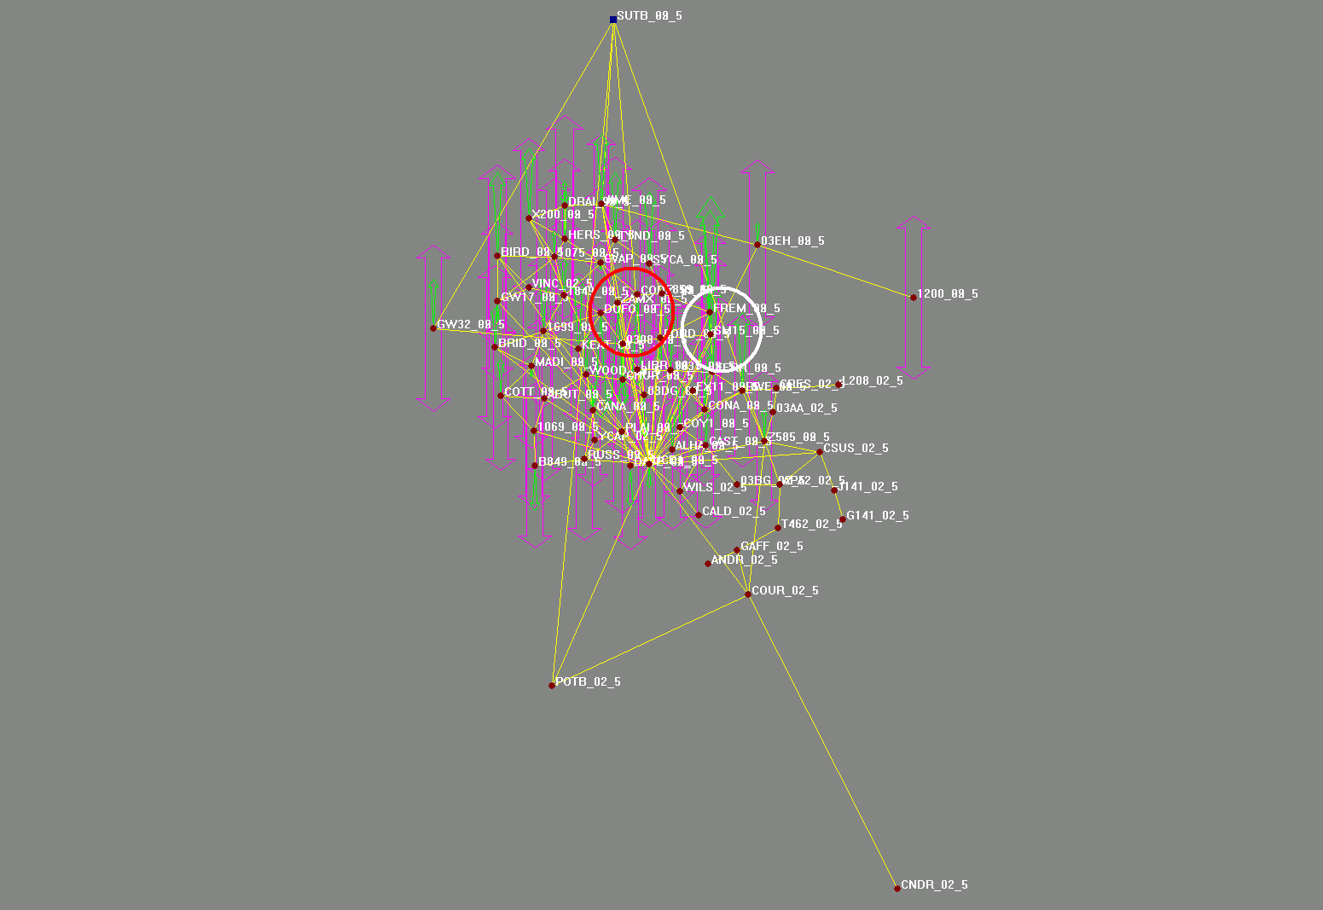
Figure 3: Yolo County subsidence regions in red, uplift in white
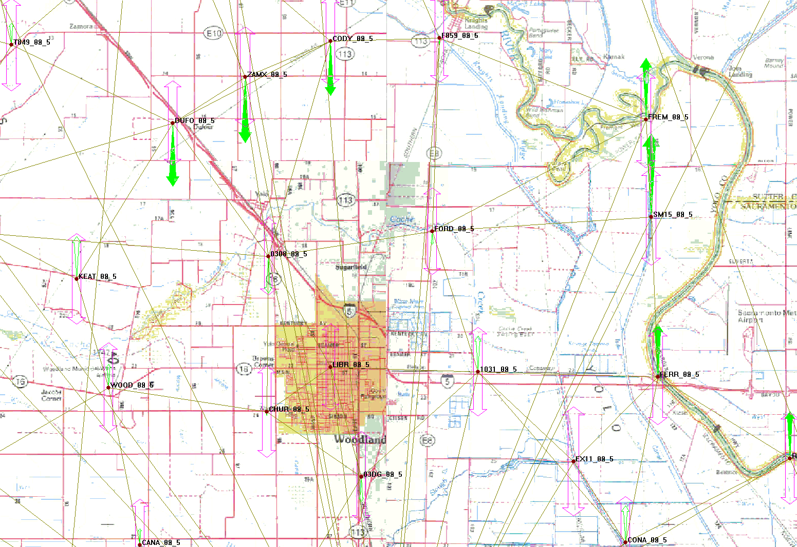
Figure 4: A closer look at the areas of vertical deformation in Yolo County

